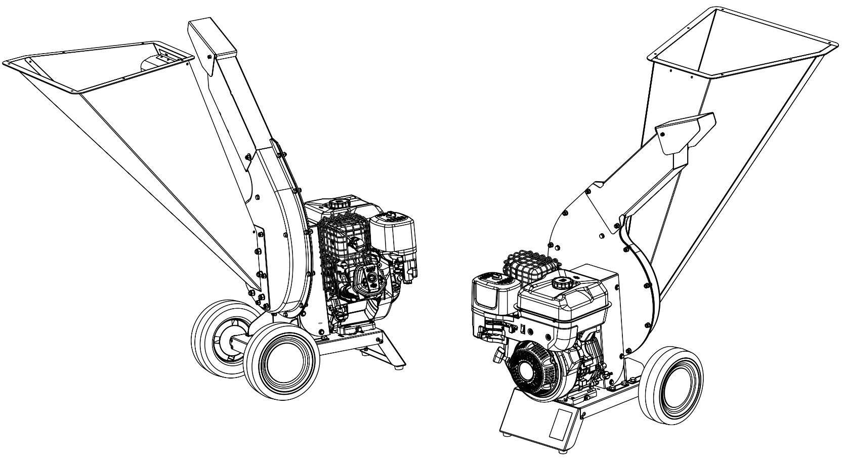

BIOSHREDDER
SERIES ZARA

OPERATOR OWNER’S MANUAL – SAFETY WARNINGS – MAINTENANCE
AGRINOVA s.r.l. - Via 24 Maggio,26 35010 Curtarolo (PD) www.agrinova-italia.it

SUMMARY

SUMMARY 3
INTRODUCTION 5
ABOUT THIS MANUAL 6
1. UPDATING THE MANUAL 6
2. COPYRIGHT 6
ABOUT THE MACHINE 7
3. INTENDED USE 7
4. DESCRIPTION – MODELS – TECHNICAL SPECIFICATIONS 7
5. OPERATING PRINCIPLE 10
6. USE ADVICES 10
7. CONTENT OF THE BOX 11
8. DISCHARGE TUBE ASSEMBLY 11
9. HOPPER ASSEMBLY 11
SAFETY INFORMATIONS 12
10. SAFETY REGULATIONS 12
11. PREPARATION 12
12. OPERATION 13
13. MAINTENANCE AND STORAGE 14
14. FIRE SAFETY PRECAUTIONS 15
15. STORAGE 16
16. MACHINE DISPOSAL 16
17. TRANSPORTING THE MACHINE BY VEHICLE 17
18. ROAD TRANSIT 17
SAFETY SIGNALS 18
19. DESCRIPTION OF SAFETY DECALS 18
20. TECHNICAL IDENTIFCATION AND CE MARKING LABEL 19
USE – OPERATING STAGES 20
21. USE – GASOLINE ENGINE VERSION 21
MACHINE MAINTENANCE 21
22. FIRST-TIME USE – PUTTING BACK INTO SERVICE AFTER A LONG PERIOD OF DISUSE 21
23. CLEANING THE CUTTING CHAMBER - KNIVES CHECK 22
24. CUTTING CHAMBER CLEANING 23
PTO VERSION 24
25. RE-FILLING / CHECKING OIL LEVEL IN THE MULTIPLIER 24
26. ADDITIONAL SAFETY INSTRUCTION – PTO VERSIONS 25
27. LINK – START – OPERATING STAGES - STOP 26
28. CONNECTION – USE - STOP 27
SPARE PARTS 29
WARRANTY 29
EC CONFORMITY DECLARATION 30
CONTACTS 32

INTRODUCTION

This manual contains operation descriptions and the necessary instructions for performing the main operations concerning use, routine and periodical maintenance of the machine correctly.
To make consultation easier, this manual has been divided into easily identifiable chapters.

The instructions in this manual are for professional users, who must have specific familiarity with the way in which the machine is used as well as being authorised, instructed and suitably trained to do so.

We recommend that you always use original spare parts and accessories. As well as make the warranty null and void, the use of non-original parts could be hazardous and reduce the duration and performance of the machine.

If the machine is sold on or ownership is transferred, it must always be accompanied by this manual. If the manual is damaged or lost, please contact AGRINOVA s.r.l. or the previous owner. The manual is considered an integral part of the machine.

It is fundamentally important that you read this manual with care before you put your WOOD CHIPPER into operation.

AGRINOVA SRL cannot be held responsible for strict or any other form of liability in the event of failure to abide by the instructions and regulations stated in this manual.

FOR YOUR OWN SAFETY, NEVER FORGET:

- ALWAYS to remove the cap on the spark plug cable while carrying out maintenance and/or cleaning operations to prevent any accidental start up.

- ALWAYS to keep hands and feet well away from moving or rotary parts.

- ALWAYS to keep fuel in certified safety containers.

ABOUT THIS MANUAL

This manual is to be considered an integral part of the machine, which it must accompany in the event that it is sold on and until it is demolished.

If the manual is lost or damaged, please contact the manufacturer for another copy: AGRINOVA s.r.l. Via 24 Maggio, 26 35010 Curtarolo (PD) ITALY

Special decals are affixed to the machine and the operator is responsible for keeping them perfectly visible and for replacing them when they are no longer legible.

THIS SYMBOL MEANS IT IS NECESSARY TO PAY THE UTMOST ATTENTION TO THE SUBJECT CONCERNED.

This manual also contains an annexed EC Conformity Declaration.
It is possible that some devices mentioned in this manual have not been fitted to your machine; this will depend on the model and equipment chosen and on the destination market of the machine itself.

- UPDATING THE MANUAL

The information, descriptions and illustrations in this manual truly reflect the state of the art at the time that the machine was sold.
The manufacturer reserves the right to make any changes to the machine it deems fit for reasons of a technical or commercial nature.
These changes in no way oblige the manufacturer to intervene on any machines sold up to that time, nor to consider this manual inadequate.
Any integration deemed necessary and subsequently supplied by the manufacturer must be kept with the manual and considered an integral part of it.

- COPYRIGHT

The copyright of this manual is owned by AGRINOVA s.r.l.
This manual contains texts, drawings and illustrations of a technical type, which cannot be disclosed or transmitted to other parties, either wholly or in part, without the prior written consent of AGRINOVA s.r.l.

ABOUT THE MACHINE
- INTENDED USE

We congratulate you on your choice of a ZARA Series chipper. The excellent quality of the materials used and the experience gained in more than ten years of activity by the company AGRINOVA guarantee maximum reliability and the ability of this device to meet all requirements of shredding.

This chipper is a device that allows you to shred branches of various sizes, leaves, wilted flowers, mowed grass and waste from cutting gardening or resulting material from pruning trees, hedges and shrubs.

The material inserted in the machine is almost completely shredded by the chipper's knife cutting system, which easily solves the problem of disposing of the massive mass of organic waste. The shredded material is transformed into humus by means of a special treatment, and can be used without any contraindications as an organic fertilizer. If you want to speed up the decomposition process, the waste can be placed in a pile of compost.

ANY OTHER USE SHOULD BE CONSIDERED IMPROPER AND THEREFORE, PROHIBITED.

- DESCRIPTION – MODELS – TECHNICAL SPECIFICATIONS

The next pages describe the main characteristics of the Shredder Series ZARA in the gasoline engine version.

Pay attention and memorize the major components based on the model of the machine in your ownership.

THE MACHINE IS DELIVERED WITHOUT ENGINE OIL.
CHECK THE ENGINE OIL LEVEL BEFORE SWITCHING ON TO PREVENT SERIOUS ENGINE DAMAGE.
PLEASE CONSULT THE ENGINE MANUAL FOR THE TYPE-QUALITY-AMOUNT OF OIL TO USE.

Component description (in figure ZR80B).
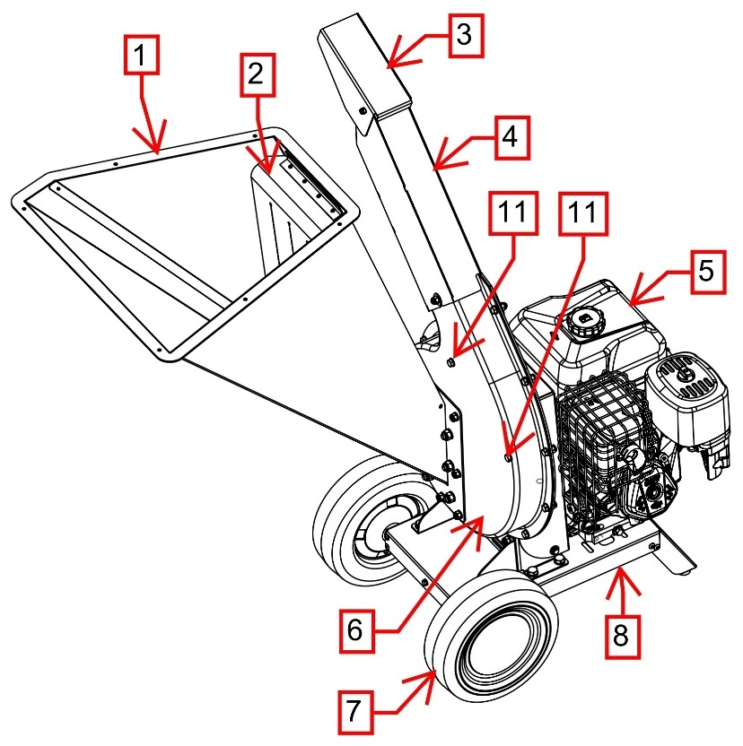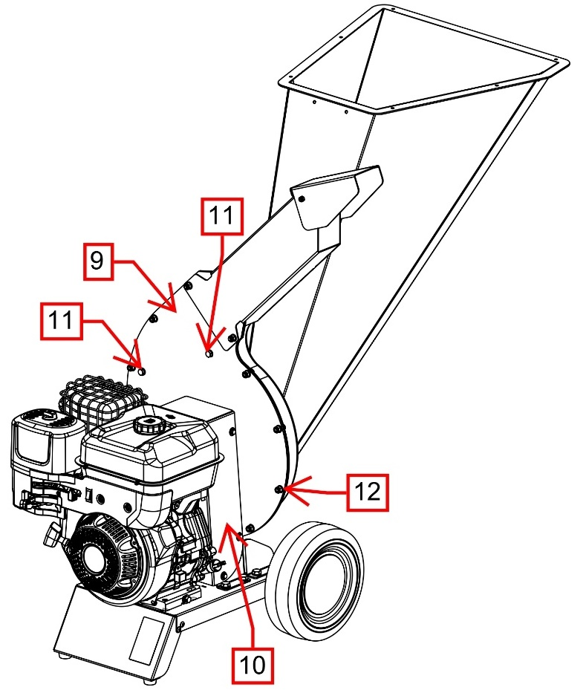

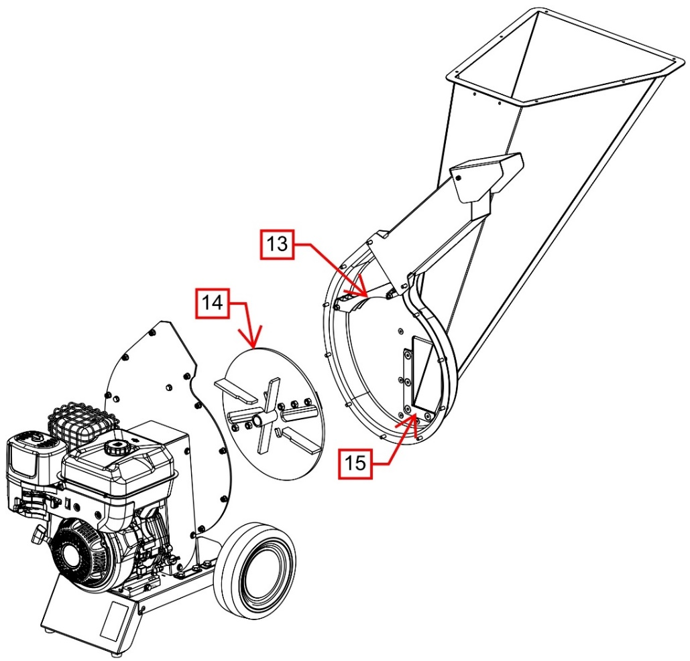
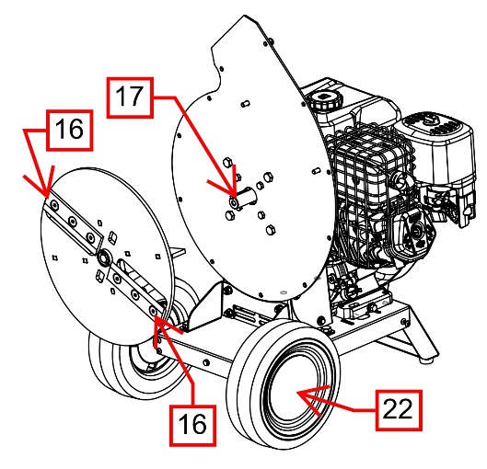
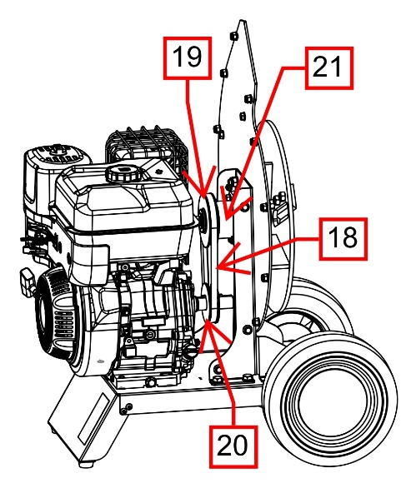

COMPONENT TABLE
NR | DESCRIPTION | NR | DESCRIPTION
1 | Long Hopper | 12 | Cutting chamber screws
2 | Safety rubber | 13 | Sieve
3 | Deflector | 14 | Cutting disc
4 | Discharge tube | 15 | Counter-knife
5 | Engine | 16 | Tempered Knives
6 | Cutting chamber housing | 17 | Cutting disc shaft
7 | Wheel | 18 | Transmission belt
8 | Base plate | 19 | Cutting disc pulley
9 | Rear cutting chamber plate | 20 | Engine pulley
10 | Belt cover | 21 | Cutting disc shaft hub
11 | Sieve screw | 22 | Wheel cover

VERSION TABLE
Model | Engine | Engine mod. | HP | KW | Rpm | Max. choppable Ø  (average wood hardness)
ZR80H | Gasoline | Honda GX270 | 9* | 6.71 | 3600 | 70 mm
ZR80B | Gasoline | B&S Series 1450 | 10 | 7.36 | 3600 | 70 mm
*Potenze a 3600 rpm Ref. SAE J134

TECHNICAL SPECIFICATIONS TABLE
Working position measures | 1250x900x1200 H mm – engine versions
Peso | 85 kg
Transmission type | 1 or 2 V-belt (depends on version)
Cutting system | Disc system – Ø590 mm
Knives nr. | 2 – core tempered steel
Feeding type | Freefall type

- OPERATING PRINCIPLE

The engine via a direct link turns the cutting unit used for the cutting, chopping and reduction of the material. The material introduced into the hopper falls towards the cutting unit and first passes through the cutting knives and subsequently through the hammers that sap and reduce the volume of the material introduced. In particular the hammers work in combination with the counter-knives placed at the periphery of the cutting chamber contributing to the refining of the output material. All this in combination with the shape of the cutting chamber formed by two shells of pressed sheet metal in the shape of spiral favors the creation of the airflow, contributing to the optimal processing of the material without clogging.
- USE ADVICES

The ZARA Series chipper, like all other machines, requires a period of learning by the operator in which to pay particular attention both from the point of view of use and safety.
Finally, a correct insertion of the material is essential for a satisfactory use of the machine.
Below you will find some advice on how best to use the chipper:
1) Do not insert excessively damp or resinous material all at once, this could block the cutting mass and lead to the engine being switched off.
If possible, alternate between wet and dry material to aid discharge.
2) Do not insert excessively hard material.
This could lead to damage to the knives and overload of the motor.
3) Do not insert material from pruning too leafy, if necessary, thin the branches so as not to overload the machine.
4) NEVER insert material containing nails, staples, pieces of wire, dirt, stones, etc.. This could lead to damage to the knives and overload of the motor.
5) In case of overload of the cutting mass and a consequent decrease of the motor revolutions, give the time to the machine to discharge and to the motor to resume the maximum revolutions before inserting more material.
6) If abnormal vibrations are noticed after the insertion of resinous or very humid material, switch off the engine, wait for it to stop completely, disconnect the spark plug cable or the electric cable from the socket and check that the cutting mass is not clogged and that the exhaust curve is free.

- CONTENT OF THE BOX

To reduce the packaging space required, some chipper components are removed and are located inside the box.
When you open the box there must be these components inside:
- ZARA Series Chipper
- Wood chipper operation and maintenance manual (this manual)
- Engine operation and maintenance manual (depending on version).
- Hopper with relative fixing screws.
- Exhaust pipe with relative fixing screws

Before any type of operation you must proceed to the Assembly of Hopper.

- DISCHARGE TUBE ASSEMBLY
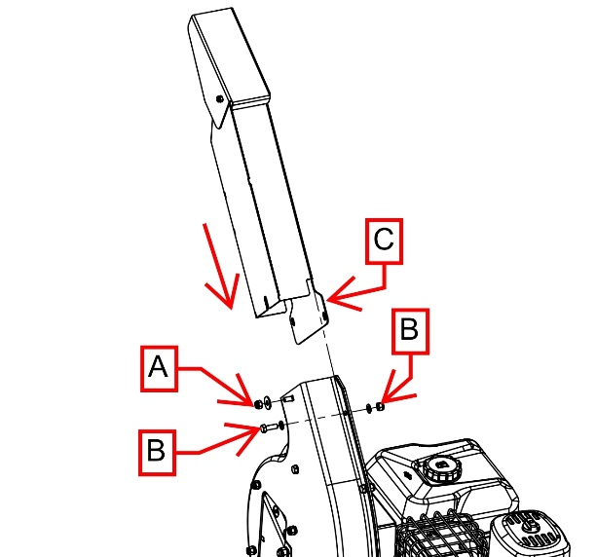
Valid for all versions.

Take the exhaust pipe C and insert it into the mouth of the cutting chamber.
Secure well using screws B and nut A.

- HOPPER ASSEMBLY
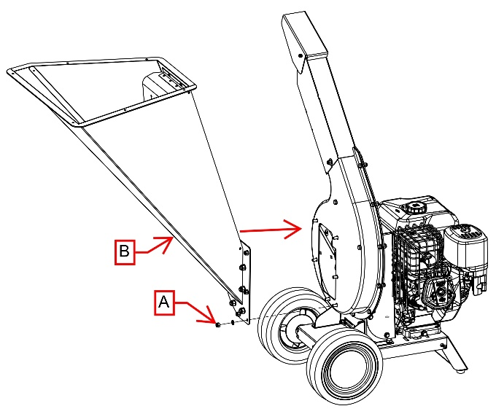
Valid for all versions.

Take hopper B and insert it into the screws protruding from the mouth of the cutting chamber.
Secure well using screws A.

SAFETY INFORMATIONS

Read all instructions with care before using the bio shredder; in case of doubt, contact the technical staff at the manufacturer’s dealer.
The manufacturer cannot be held liable for failure to abide by the safety and accident prevention regulations listed here below.

Correct use of the machine, strict compliance with the standards and regulations included in this manual and stringent application of all precautions necessary to prevent any dangerous situations will eliminate the risk of accidents and injury, allow the machine to work better and for longer and also reduce breakdowns to a minimum.

The following section describes the operations for safe machine use. Read with care.

- SAFETY REGULATIONS

DO NOT ALLOW PERSONS UNFAMILIAR WITH THESE INSTRUCTIONS OR CHILDREN TO USE THE MACHINE.

PEOPLE UNDER THE AGE OF 16 ARE FORBIDDEN TO USE THIS MACHINE;

rEMEMBER THAT THE OPERATOR OR USER IS RESPONSIBLE FOR ACCIDENTS OR DANGER INVOLVING OTHER PEOPLE AND/OR THEIR PROPERTY.

Make sure you are familiar with the contents of the owner’s manual before trying to operate this machine.

- PREPARATION

- Never use the machine if there are people, especially children, or pets in the proximity of it;
- Never allow children to operate this machine;
- By-laws regulating operator age limits may be in force;
- Never operate this equipment in proximity to those not involved with the job;
- Never use machines driven by engines in closed areas since the exhaust gases contain carbon monoxide, which is colourless, odourless and tasteless; Carbon monoxide is extremely dangerous in closed environments
- Always wear ear protection and safety goggles every time that you use the machine;

- Never wear loose clothing or clothing with hanging laces or cords;
- Only operate the machine in open spaces (for example, never close to walls or other fixed items) and on flat even surfaces;
- Operate the machine on the ground, on a flat and solid surface, with the brake engaged and all guards locked in place and in good light and visibility conditions;
- Before starting the machine, make sure that all screws, nuts, bolts and other fastenings are well tightened and that all guards and covers screens are in place. Replace any damaged or illegible decals;
- Take great care when handling fuels; these are flammable substances and the fumes are explosive;
- Agrinova srl cannot account for every type of unforeseen improper use that may involve a potential hazard;
- The decals affixed to the machine provide important information: abiding by these indications is important for your safety;
- Do not work on muddy, sandy or loose earth;
- Never use the machine to carry people, animals or items;

- OPERATION

- Before starting up the machine, make sure that the feed chamber is empty;
- Keep your face and body well away from the feed opening;
- Never allow hands, other parts of the body or clothing to enter the feed chamber or discharge chute or to come close to moving parts;
- Maintain balance and stability. Never stretch out. Never stand on a level that is higher than the machine base when inserting material;
- Always stay well away from the discharge area when starting up the machine;
- When feeding material into the machine, take great care not to insert pieces of metal, rock, bottles, cans or other foreign bodies;
- If the cutting mechanism should come up against foreign objects or the machine should start to make unusual noises or vibrate strangely, switch off the engine and stop the machine. Disconnect the spark plug cable from the spark plug and proceed as follows:
- Check the damage;
- Check and tighten any parts that have come loose;
- Have any damaged parts repaired or replaced with parts that have the same specifications.
- Do not allow processed material to build up in the discharge area; this situation could prevent the correct discharge, causing material to return back through the feed opening;
- If the machine should become clogged, switch off the engine and disconnect the spark plug cable before removing any debris. Keep the engine free of debris and other build up to prevent damage and possible fire.
- Remember that when the machine ignition is started, the cutting device is started at the same time;
- Keep all guards and deflectors in place as well as in the proper working order;
- Never tamper with the settings of the engine regulator; the regulator controls the maximum safe operating speed and protects the engine and all moving parts against the damage caused by increased speed. Contact your nearest authorised assistance service should a problem occur;
- Never transport this machine with the engine switched on;
- Switch off the engine and disconnect the spark plug cable each time that you leave the work area;
- Never tilt the machine while the engine is running.

- MAINTENANCE AND STORAGE

- When the machine is idle for assistance interventions, checks or storage, or to change an accessory, switch off the engine, disconnect the spark plug cable from the spark plug and make sure that all moving parts are no longer moving, then remove the key (if present). Allow the machine to cool before carrying out any inspections or adjustments, etc.
- Store the machine where fuel fumes cannot be exposed to naked flames or sparks. If storing for significant periods, drain out the fuel. Always leave the machine to cool down before placing it in storage;
- During assistance interventions on the cutting device, remember that even if the engine will not switch on, thanks to the option to block the guard, the cutting device can always be moved by the manual starting mechanism.
- FIRE SAFETY PRECAUTIONS

- It is advisable for staff in charge of the machine to be aware of the main intervention procedures in case of fire.
- All fuels and the majority of lubricants and hydraulic fluids are flammable.
- Never smoke while refilling or topping up fluids; never fill with fuels near to naked flames and never siphon off fuel.
- Switch off the machine engine before filling with fuel and never fill up in closed environments.
- Before starting the machine engine, make sure that there are no leaks or residues of fuels/lubricants/fluids that could cause small fires.
- Never store flammable substances in places that are not suited to this purpose; do not pierce or burn pressurised containers or canisters; do not store materials soaked in flammable substances.
- Take care with the storage of rags or replaced parts that might contain flammable residues.
- To reduce the risk of fire to a minimum, clean the machine regularly with the relevant equipment (compressed air).
- Use appropriate extinguishing means: carbon dioxide, foam, chemical powder.
- Never use jets of water. Jets of water should only be used to cool down surfaces exposed to fire.
- Never use petrol, solvents or other flammable or toxic fluids to clean mechanical parts; use approved commercial solvents that are non-flammable and non-toxic.
- Only used approved containers;
- Never remove the fuel cap or add fuel while the engine is running.
- Before filling with fuel, leave the engine and exhaust outlets to cool;
- Never leave the machine or fuel container in places where there are naked flames;
- In the event of fuel spillage, never try to start the engine; move the machine away from the area of the spill before switching on;
- After filling with fuel, always close the cap and fix it securely in place;
- The fuel tank must only be drained out of doors.

- STORAGE

If the machine is not going to be used for a long period, it is necessary to store it in a place sheltered from the elements and to protect it against any damage. Before storing the machine, we recommend cleaning it thoroughly and lubricating all mechanical parts to protect against rust.
Make sure that the storage temperature is between 0 °C and 50 °C.
Before storing the machine for long periods, proceed as follows:
- Switch off the engine and remove the spark plug cap
- When the engine is cool, drain out the petrol tank, well away from sources of heat, sparks and lit fires;
- Position the machine in transport mode;
- Free the cutting unit from any shredded debris;
- Clean the machine carefully;
- Carry out a general visual inspection of the machine to identify structural damage and deep scratches in the paintwork; make sure that the original safety decals are present, undamaged and legible;
- Grease all mechanical parts, where this is necessary;
- If possible, place the machine in a covered area, on a flat, firm surface.

- MACHINE DISPOSAL

If the machine is to be scrapped, it needs to be disposed of at suitable collection points, in compliance with current laws.
Before proceeding to scrap the machine, it is necessary to separate plastic or rubber parts and electrical and electronic materials.
Recover any spent oils and dispose of them at special collection centres.

USED OIL MUST BE RECOVERED AND NEVER DISPOSED OF INCORRECTLY SINCE ACCORDING TO CURRENT LAWS AND REGULATIONS, IT IS CLASSIFIED AS HAZARDOUS WASTE AND AS SUCH, IT NEEDS TO BE TAKEN TO A SPECIAL COLLECTION CENTRE.

The parts made solely in plastic, aluminium or steel can be recycled, if taken to the relevant collection centres.

- TRANSPORTING THE MACHINE BY VEHICLE

The machine can only be transported by vehicle when switched off and secured with the relevant cords and all of the equipment required for the vehicle to transport it in compliance with the regulations in force.

IT IS NOT PERMITTED TO USE THE MACHINE ON A MEANS OF TRANSPORT, SUCH AS, FOR EXAMPLE, THE BED OF A LORRY, INSIDE A VAN, ETC., ETC. tHE MACHINE MUST BE OPERATED ON THE GROUND, ON A FIRM AND FLAT HORIZONTAL SURFACE, WITH THE BRAKE ENGAGED AND ALL GUARDS LOCKED IN PLACE.

- ROAD TRANSIT

ROAD TRANSIT WITH THE MACHINE IS STRICTLY PROHIBITED.
THE MACHINE CAN BE MOVED BY HAND IN PRIVATE AREAS ONLY, FOR SHORT DISTANCES AND AT LOW SPEEDS.

NOTE: The wheels are suitable only for short trips.

SAFETY SIGNALS

Make sure that the safety decals are in good condition. If decals are damaged, they need to be replaced with other originals that can be requested from the manufacturer and then placed in the positions indicated in the use and maintenance manual.
Make sure that the safety decals are legible. Clean with a cloth, soap and water.

- DESCRIPTION OF SAFETY DECALS

The following section describes the safety decals on the machine; read with care.

Cod.ET103 WARNING–DANGER
(Gasoline version)Adjustment/maintenance operations must be performed after reading the use and maintenance manual, with the machine idle and the spark plug cable disconnected. Danger of flying objects. Cutting hazard. Keep all people not involved in the job at a safe distance.
Cod.ET117 WARNING–DANGER of cutting. Keep hands and feet well away from cutting parts.

Cod.ET201 Wear the required Personal Protective Equipment: Goggles, Headset, and Gloves.

Cod.ET109 WARNING – DANGER of contact with moving parts. Do not place hands in the vicinity of the transmission belts. Do not wear loose and/or bulky clothing.

Cod.ET122 WARNING – DANGER of ejected items. Stand back.

IF THE SAFETY DECALS BECOME WORN, THEY MUST BE REPLACED AND PLACED IN THE POSITION INDICATED BY THE USER'S MANUAL

- TECHNICAL IDENTIFCATION AND CE MARKING LABEL

This is the label identifying the machine and indicating the type and version, manufacture date, power, weight, noise levels and CE marking.
This label, like the safety decals, needs to be legible and in good condition.

USE – OPERATING STAGES

The following section describes the operations required for the safe use of the machine.

THE MACHINE MUST OPERATE ON FLAT, FIRM GROUND WITH THE BRAKE ENGAGED AND ALL GUARDS LOCKED IN PLACE.

SPECIFICALLY, MAKE SURE THAT THE THE HOPPER AND THE CUTTING CHAMBER ARE PROPERLY LOCKED IN POSITION.

To switch on, use and switch off the engine, refer to the specific manual, supplied with the machine.
THE MACHINE IS DELIVERED WITHOUT ENGINE OIL.
CHECK THE ENGINE OIL LEVEL BEFORE SWITCHING ON TO PREVENT SERIOUS ENGINE DAMAGE.
PLEASE CONSULT THE ENGINE MANUAL FOR THE TYPE-QUALITY-AMOUNT OF OIL TO USE.

- Since the mechanical parts and hydraulic connections of the machine need time to settle in during the first stage of the machine’s useful life, it is indispensable to carry out machine checks with the utmost accuracy.
- Before using the machine, make sure that there are no people or animals within its range of action.
- It is strictly prohibited to remove and/or modify protections on the machine.
- Never use the machine if you are ill, tired or under the effect of medicines, drugs or alcohol.
- Before using the machine, it is necessary to learn the layout and functions of its controls.

- USE – GASOLINE ENGINE VERSION

- Wear all required personal protection equipment.
- Check the engine oil and fuel levels.
- After switching on the engine and leaving it to warm up for about 2 minutes.
- The machine is ready for use.
- Set the speed of the engine at full throttle.
- Let the engine gain full rpm.
- Adjust the sieve aperture.
- Place the material into the hopper.
- At the end of use, take the engine to minimum running speed, wait for it to achieve this and then switch it off using the relevant control;
- Wait for the engine to cool before storing the machine

MACHINE MAINTENANCE

The following section describes the machine maintenance operations; read with care.

AFTER THE ENGINE HAS BEEN SWITCHED OFF, THE CUTTING UNIT WILL CONTINUE TO TURN FOR 10-15 secondS BEFORE STOPPING COMPLETELY.
ALWAYS WAIT FOR THE CUTTING UNIT TO STOP COMPLETELY BEFORE CARRYING OUT ANY MAINTENANCE OR CLEANING OPERATION.

all maintenance, adjustment and cleaning operations must only be carried out with the engine switched off and cool and with the spark plug cable (or power cable) disconnected.

- FIRST-TIME USE – PUTTING BACK INTO SERVICE AFTER A LONG PERIOD OF DISUSE

Before using the machine for the first time, or after a long period of disuse, it is necessary to proceed as follows:

- Make sure that the machine shows no signs of damage;
- Check mechanical parts, which must be in good condition and free of rust;
- Check the knife for wear and tear;
- Make sure all protections are in correct position.
- Check engine oil level.
- Carry out a general visual inspection of the machine to identify structural damage and deep scratches in the paintwork; make sure that the original safety decals are present, undamaged and legible.

- CLEANING THE CUTTING CHAMBER - KNIVES CHECK

A constant check of knives, cleaning the cutting unit, the cutting chamber and the discharge curve always guarantee an optimal use of the machine preventing any overloading of the engine and imbalance.

ANY TYPE OF MAINTENANCE OPERATION, CONTROL, CLEANING MUST BE MADE WITH THE ENGINE OFF AND COLD WITH SPARK PLUG CABLE DISCONNECTED. IN THE EVENT OF ELECTRIC MOTOR VERSION UNPLUG THE POWER CORD FROM THE WALL .

To check the state of wear of the knives need to open the cutting chamber.
Proceed as follows:
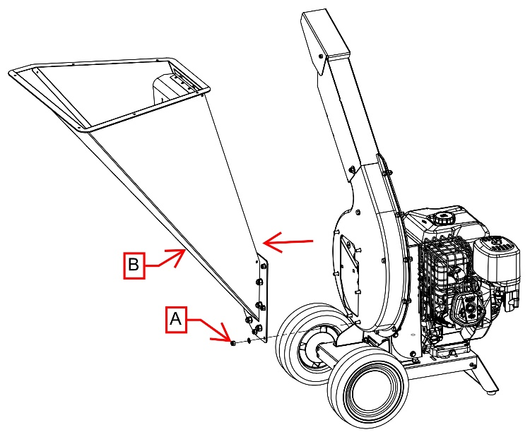
When the machine is switched off and stopped
Unscrew the screws "A" and remove the hopper "B".
Check the state of wear of the knives by turning the cutting disc by acting on the engine ignition cord.
At the end, refit the hopper.

CAUTION RISK OF CUTTING AND CRUSHING. EXERCISE EXTREME CAUTION .
EVEN IF THE ENGINE IS OFF THE CUTTIN UNIT IS HOWEVER FREE TO TURN AND CAN CAUSE SERIOUS INJURY OR ACCIDENT .
- CUTTING CHAMBER CLEANING

In case of clogging of the machine and/or removal of the sieve
Proceed as follows:
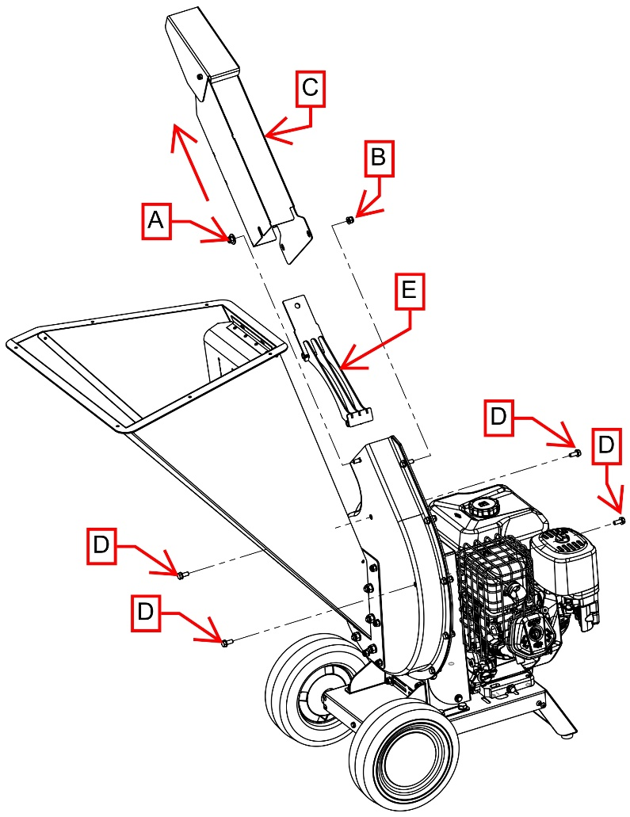
With the machine switched off and stopped.
Unscrew screw "A" and "B", remove exhaust pipe "C".
Unscrew the 4 screws "D" and remove the sieve "E".

At the end of the operation, refit the sieve and discharge pipe, or only the discharge pipe if desired.

CAUTION RISK OF CUTTING AND CRUSHING. EXERCISE EXTREME CAUTION .
EVEN IF THE ENGINE IS OFF THE CUTTIN UNIT IS HOWEVER FREE TO TURN AND CAN CAUSE SERIOUS INJURY OR ACCIDENT .

PTO VERSION

Use of the chipper with 3 points connections version is similar to the use of gasoline engine version, although further safety instructions involving the link of the chipper to tractor, its use and moving / transport.
Read carefully and understand all the instructions described here below.

- RE-FILLING / CHECKING OIL LEVEL IN THE MULTIPLIER

THE BIO Chipper IS SOLD WITHOUT OIL IN THE MULTIPLIER.
BEFORE USING THE FIRST TIME, FILL WITH OIL TYPE SAE90.

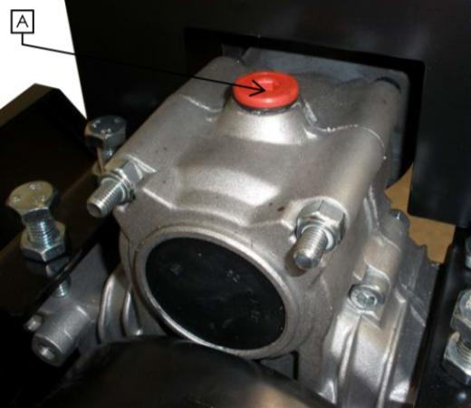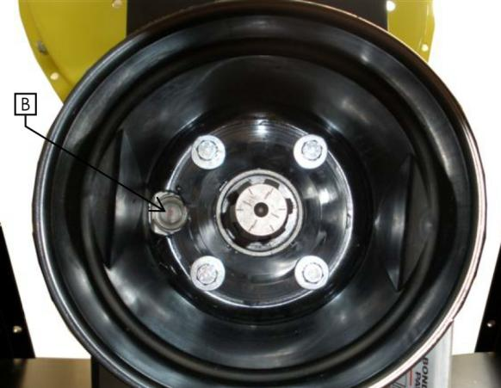
A: FILLING POINT
B: CHECK POINT
CHECK EVERY 50 HOURS OF WORKING THE OIL LEVEL IN THE
MULTIPLIER. FILLING UP, IF NECESSARY, WITH OIL OF A GOOD QUALITY
TYPE SAE90.

- ADDITIONAL SAFETY INSTRUCTION – PTO VERSIONS

- Read the instructions on the safety labels of PTO and follow them with great care.
- Read the instructions in the use and safety manual of the PTO joint and follow them with great care
- Read the instructions in the use and safety manual of the tractor to whom the bio chipper will be connected and follow very carefully.
- Use only PTO joints respecting the safety level as mentioned in regulations in force.
- Be careful when you use PTO.
- Keep the bystander, especially children and/or no-operator, away from the transmission line of PTO and the bio chipper.
- It is mandatory to connect the Bio chipper and the tractor using all 3 points connection, according to rules in force.
- Check that the link between the bio chipper and the 3 points connection has been carried out properly; keep in safety the connection pins with their own safety plugs.
- Check that the link between the bio chipper and the tractor by the PTO joint has been carried out properly.
- Check that the PTO joint respect all the safety instructions according the rules in force, that all the protections and safety chains are in good conditions and link correctly.
- Keep always all the carters and protection screens in position when using the machine.
- Disconnect PTO, switch off the tractor, remove the switching on key, disconnect the PTO joint and make sure that all the moving parts come to a complete stop before removing carter and protection screen and before doing every maintenance, control and cleaning action.
- Clothes worn by the operator have to be perfectly close fitting.
- Never wear jackets, shirts, belts, large trousers, working around PTO and/or the cardan joint.
- Link your long hair behind the back of the neck or put them under a cap.
- Avoid that hydraulic pipes, electric cables, chains, ropes and other things get in touch with PTO and the cardan joint.
- Do not exceed in speed than 540+-10 revolutions per minute about PTO.
- Check the correct cardan joint rotation.
- Keep your hands, feet and clothes away from all the components of PTO transmission and of the cardan joint.
- Do not clean, lubricate or adjust the cardan joint when it is working.
- Keep away from the moving parts.
- The bio chipper has a mass of about 210 kilos, so it is necessary to verify that the tractor has a power and a mass suitable for connection/transport/ using of the bio chipper.
- In case of transport on a public road by a tractor, respect all the Highway Code rules, using the adequate signs of advice and danger, according to rules in force.
- IT IS STRICTLY FORBIDDEN using the bio chipper moving, the tractor has to be stopped and braked, on a flat surface, away from any kind of obstacles.
- IT IS MANDATORY moving/transport the bio chipper using all 3 points connection.

The machine has to be linked to the tractor PTO of at least 20HP with a speed equal to 540 rpm. The rotation sense of the tractor PTO has to be clockwise to an observer that is looking at the PTO in front.
It needs to be used a cardan joint with some features correspondent to rules in force.
Check these features directly from documents of the tractor and from the same cardan joint. Always verify, in every case, the efficiency of the protection carter on the power take-off of the Tractor, on the chipper and on the cardan joint.
The entire transmission unit has to be protected.

The transmission at cardan joint could be very dangerous in the case that some safety rules are not observed. In the instruction manual, you will find more prescriptions about the cardan joint.
First, we recommend you to check that the carter on the tractor side and on the bio chipper side are efficient, that are no cracks and bad working.
Verify that the PTO protection of the bio chipper integrate itself and is superimposed for at least 50 mm as in the picture below.
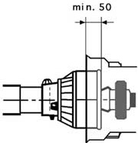

- LINK – START – OPERATING STAGES - STOP

After reading and well understood this instruction manual and following all the safety prescriptions is possible to proceed with the connection and use of the bio chipper.

- Switch on the tractor and engage PTO.
- Take gradually revolutions of PTO to 540 rpm.
- Never go beyond 540 rpm.
- Put the material into the hopper.
- When you finish your work, you have to tick over the engine, disconnect PTO and switch it off.
- Wait the rotation of PTO and all moving parts has been stopped before doing any intervention.
- At the moment of depot: disconnect the cardan joint, disconnect the 3 points connection being careful to put away the safety pins and plugs.

- CONNECTION – USE - STOP

After reading and well understood this instruction manual and following all the safety prescriptions is possible to proceed with the connection and use of the bio chipper.

Check the good conditions of carters and protection screens.
Check the oil level of the multiplier. If it is necessary, you have to fill up.
Connect the bio chipper to the tractor by the 3 points connection.
Connect the cardan joint to PTO and to bio chipper.
If present, connect ANTI-STRESS system to the tractor with 12V DC current.
If present, put ANTI-STRESS system switch to ON position.
Switch on the tractor and engage PTO.
Take gradually revolutions of PTO to 540 rpm.
Never go beyond 540 rpm.
Release the safety bar through the release lever and pull it towards you.
Place the material in the hopper; adjust the speed of feed roller depending on the type of material inserted.
At the end of work put safety bar at the stop position.
Let the machine run with zero load for at least 30 seconds.
Set the minimum speed of the engine, wait until the engine goes idle, disengage the PTO and shut it down.
Wait until the rotation of the PTO and all the moving parts has stopped before performing any type of surgery.
At the time of storage: disconnect the PTO shaft, disconnect the 12V DC connection of ANTI-STRESS system (if present), disconnect the three-point hitch, taking care to put pins and safety pins.

SPARE PARTS
Repairs and replacements must be carried out using original spare parts, which must be requested from AGRINOVA s.r.l. or an authorised dealer of same. Remember that the request for replacement parts needs to be accompanied by the following information:
machine type;
serial number;
date of purchase;
WARRANTY
For the product warranty, refer to the European standard 99/44 and its implementation in Italy.
To avail of the warranty service supplied by the manufacturer, the operator must scrupulously abide by the precautions stated in the Use and Maintenance Manual and specifically:
- comply with the limits to use as envisaged by AGRINOVA s.r.l.;
- not make any changes or variations to the machine without the explicit written approval of AGRINOVA s.r.l.;
- always carry out all of the prescribed maintenance interventions;
- always use original replacement parts;
- make sure that those people using the machine meet the necessary requirements in terms of skill and training;

The warrant will not apply in the event that any of the above conditions has not been complied with, even in part.
The warranty does not cover possible defects that could arise from improper use and it will be rendered null and void in the event of repairs, changes or any other type of intervention not performed by AGRINOVA s.r.l. or by one of its authorised dealers.

The use of spare parts not authorised by the manufacturer will render all warranties null and void as well as freeing the manufacturer or dealer of any liability arising from malfunctions or accidents.
Removing or changing guards or protections will free the manufacturer of any liability for damages caused to people and/or property.
The warranty does not cover parts that are subject to wear and tear, such as (this list includes but is not limited to the following): blades, belts ……
The engine warranty is applied and managed by the assistance network of the engine manufacturer.
EC CONFORMITY DECLARATION

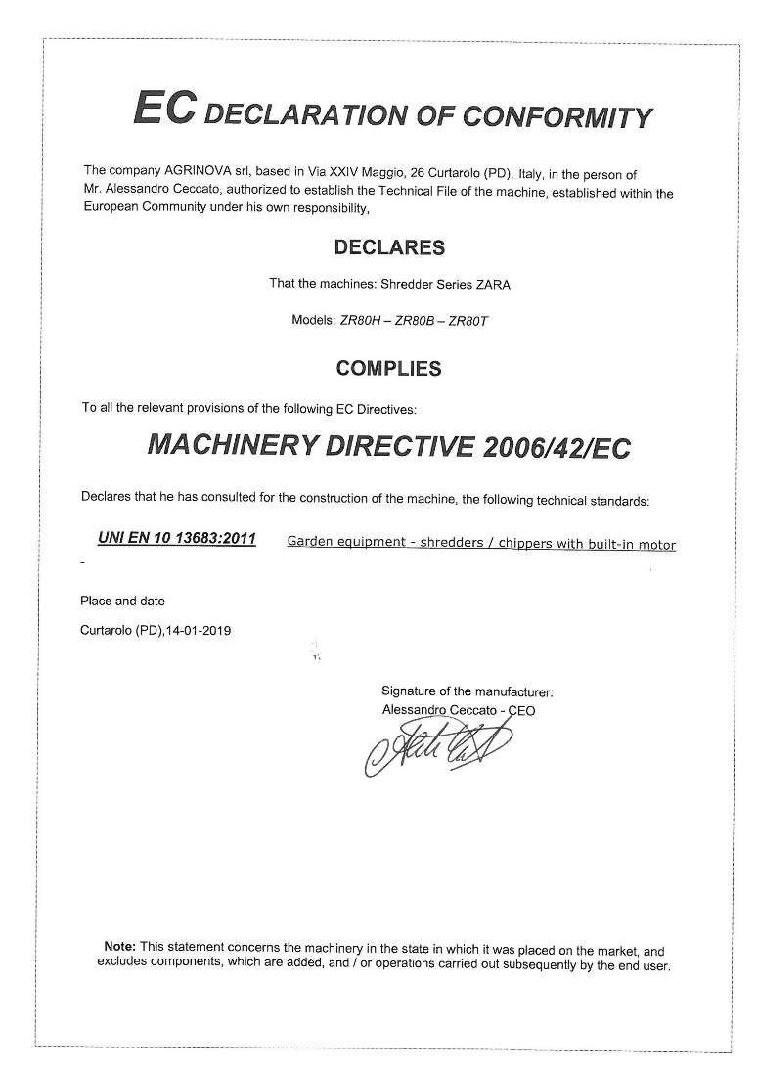

CONTACTS

For any further information, please contact us.

Agrinova s.r.l.
Via XXIV Maggio, 26
35010 Curtarolo (PD) ITALY

Tel. +39 049 5742645
Fax. +39 049 5742646

Email: agrinova@agrinova-italia.it

Web: www.agrinova-italia.it

