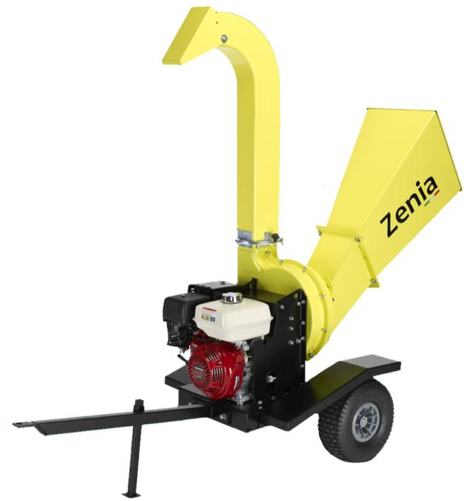

OPERATOR OWNER’S MANUAL – SAFETY WARNINGS – MAINTENANCE
AGRINOVA s.r.l. - Via 24 Maggio,26 35010 Curtarolo (PD) www.agrinova-italia.it

CONTENTS
CONTENTS 3
INTRODUCTION 5
ABOUT THIS MANUAL 6
1. UPDATING THE MANUAL 6
2. COPYRIGHT 6
ABOUT THE MACHINE 7
3. INTENDED USE 7
4. DESCRIPTION-VERSIONS-TECHNICAL SPECIFICATIONS 7
5. OPERATING PRINCIPLE 11
6. USE ADVICES 11
7. WHAT IS IN THE BOX 12
8. HOPPER ASSEMBLY 12
9. RUDDER ASSEMBLY 13
10. DISCHARGE CURVE ASSEMBLY 13
11. 3-POINT CONNECTION MOUNTING 14
safety informations 15
12. GENERAL SAFETY INSTRUCTIONS 15
13. SAFETY INSTRUCTIONS - PREPARATION 15
14. SAFETY INSTRUCTIONS – WORKING 16
15. SAFETY INSTRUCTIONS – MAINTENANCE AND STORAGE 17
16. SAFETY INSTRUCTIONS – FIRE MEASURES 17
17. SAFETY INSTRUCTIONS – STORING 18
18. SAFETY INSTRUCTIONS - SCRAPPING 19
19. SAFETY INSTRUCTIONS - TRANSPORT BY VEHICLE 19
20. SAFETY INSTRUCTIONS - ROAD TRANSIT 19
SAFETY DECALS 20
21. SAFETY DECALS – GASOLINE ENGINE VERSION 20
22. SAFETY DECAL POSITION – GASOLINE ENGINE VERSIONS 21
23. SAFETY DECALS – TRACTOR VERSION 22
24. SAFETY DECALS POSITION – TRACTOR VERSION 24
25. TECHNICAL LABEL 25
USE 25
MAINTENANCE 27
26. FIRST-TIME USING – PUTTING BACK INTO SERVICE AFTER A LONG PERIOD OF INACTIVITY 27
27. BELT REGULATION – ENGINE VERSION 28
28. BELT REGULATION – PTO VERSION 29
29. CUTTING CHAMBER CLEANING – KNIFES WEAR CHECK 30
PTO VERSION 32
30. RE-FILLING / CHECKING OIL LEVEL IN THE MULTIPLIER 32
31. ADDITIONAL SAFETY INSTRUCTION – PTO VERSIONS 33
32. LINK – START – OPERATING STAGES - STOP 35
SPARE PARTS 36
WARRANTY 36
EC DECLARATION OF CONFORMITY 37
CONTACTS 40

INTRODUCTION

This manual contains operation descriptions and the necessary instructions for performing the main operations concerning use, routine and periodical maintenance of the machine correctly.
To make consultation easier, this manual has been divided into easily identifiable chapters.

The instructions in this manual are for professional users, who must have specific familiarity with the way in which the machine is used as well as being authorised, instructed and suitably trained to do so.

We recommend that you always use original spare parts and accessories. As well as make the warranty null and void, the use of non-original parts could be hazardous and reduce the duration and performance of the machine.

If the machine is sold on or ownership is transferred, it must always be accompanied by this manual. If the manual is damaged or lost, please contact AGRINOVA s.r.l. or the previous owner. The manual is considered an integral part of the machine.

It is fundamentally important that you read this manual with care before you put your WOOD CHIPPER into operation.

AGRINOVA SRL cannot be held responsible for strict or any other form of liability in the event of failure to abide by the instructions and regulations stated in this manual.

FOR YOUR OWN SAFETY, NEVER FORGET:

- ALWAYS to remove the cap on the spark plug cable while carrying out maintenance and/or cleaning operations to prevent any accidental start up.

- ALWAYS to keep hands and feet well away from moving or rotary parts.

- ALWAYS to keep fuel in certified safety containers.

ABOUT THIS MANUAL

This manual is to be considered an integral part of the machine, which it must accompany in the event that it is sold on and until such time as it is demolished.

If the manual is lost or damaged, please contact the manufacturer for another copy: AGRINOVA s.r.l. Via 24 Maggio,26 35010 Curtarolo (PD) ITALY

Special decals are affixed to the machine and the operator is responsible for keeping them perfectly visible and for replacing them when they are no longer legible.

THIS SYMBOL MEANS IT IS NECESSARY TO PAY THE UTMOST ATTENTION TO THE SUBJECT CONCERNED.

This manual also contains an annexed EC Conformity Declaration.
It is possible that some devices mentioned in this manual have not been fitted to your machine; this will depend on the model and equipment chosen and on the destination market of the machine itself.

- UPDATING THE MANUAL

The information, descriptions and illustrations in this manual truly reflect the state of the art at the time that the machine was sold.
The manufacturer reserves the right to make any changes to the machine it deems fit for reasons of a technical or commercial nature.
These changes in no way oblige the manufacturer to intervene on any machines sold up to that time, nor to consider this manual inadequate.
Any integration deemed necessary and subsequently supplied by the manufacturer must be kept with the manual and considered an integral part of same.

- COPYRIGHT

The copyright of this manual is owned by AGRINOVA s.r.l.
This manual contains texts, drawings and illustrations of a technical type, which cannot be disclosed or transmitted to other parties, either wholly or in part, without the prior written consent of AGRINOVA s.r.l.
ABOUT THE MACHINE
- INTENDED USE

Congratulations on choosing a Shredder Series ZENIA/BIO400.
The excellent quality of the materials used and the experience gained in over ten years of activity by AGRINOVA guarantee maximum reliability of this unit and maximum shredding capabilities .
This machine is a device that allows shredding of different size branches, leaves, flowers, grass, dried cut grass and cutting waste of gardening or material results of pruning, hedges and shrubs.
The material inserted in the machine is almost completely disintegrated by cutting knives and hammers of the shredder, which resolves the problem of disposing of voluminous mass of organic waste.
The shredded material is transformed into humus through special treatment, and can be used as organic fertiliser.
If you want to speed up the decomposition process, the waste may be placed in a composter.

ANY OTHER USE SHOULD BE CONSIDERED IMPROPER AND THEREFORE, PROHIBITED.

- DESCRIPTION-VERSIONS-TECHNICAL SPECIFICATIONS

The following pages describe the main features of Shredder Series ZENIA/BIO400, on page 8 in the gasoline engine model (specifically the model ZE400-H) and on page 9 tractor model (specifically the model ZE400-T1).

Pay attention and remember the main components depending on the model of your machine.

NOTE: The raised discharge curve (optional) as shown on page 8, allows you to raise the height of discharge of 60 cm from the exhaust standard curve and can be applied to all models of shredders series ZENIA/BIO400. Contact your local reseller for more information.

Display of components. Gasoline engine version (in figure ZE400-H).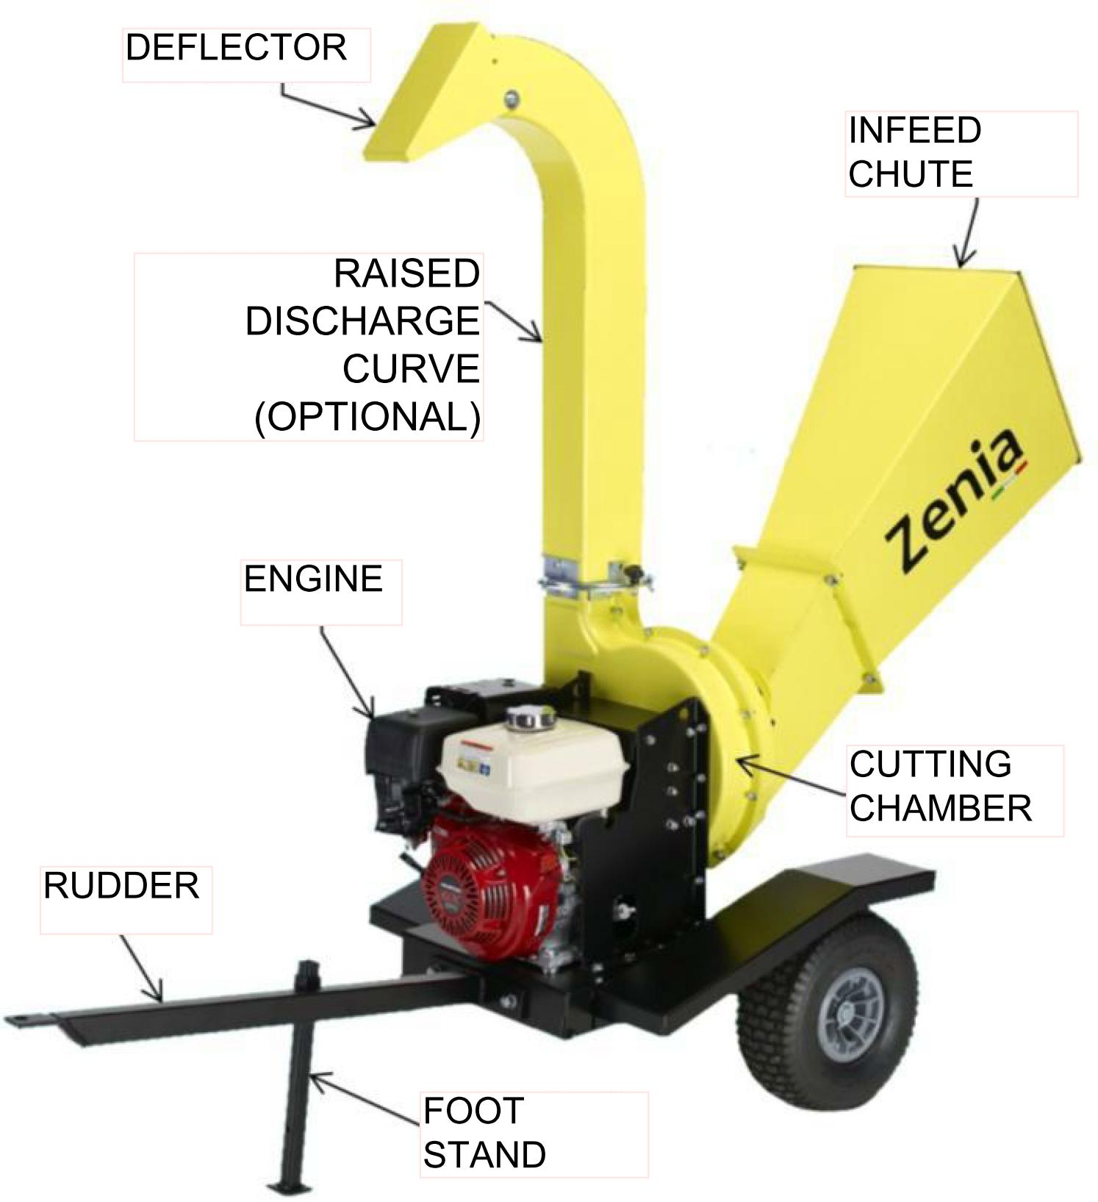
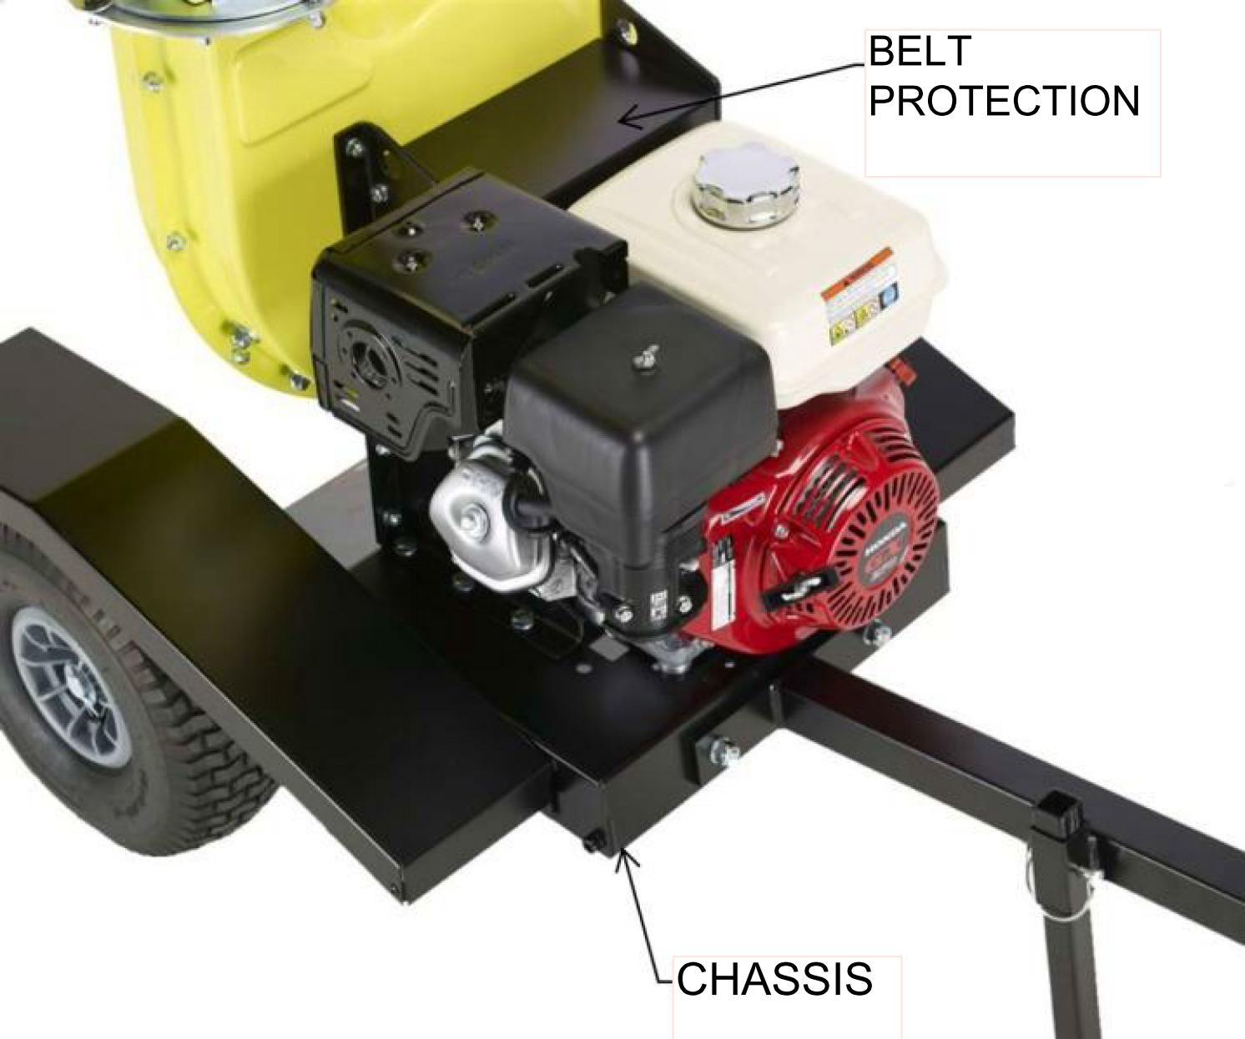

Display of components. Tractor version (in figure ZE400-T1).
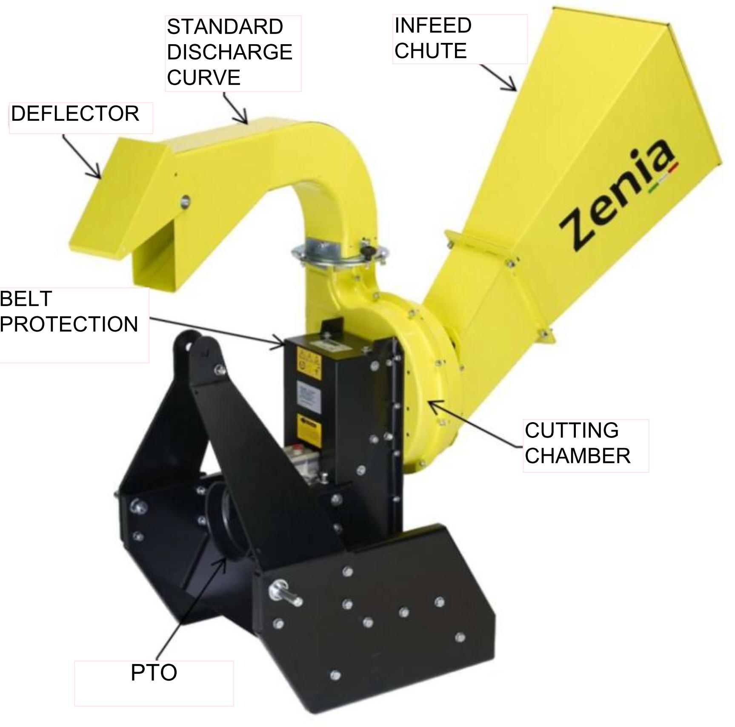
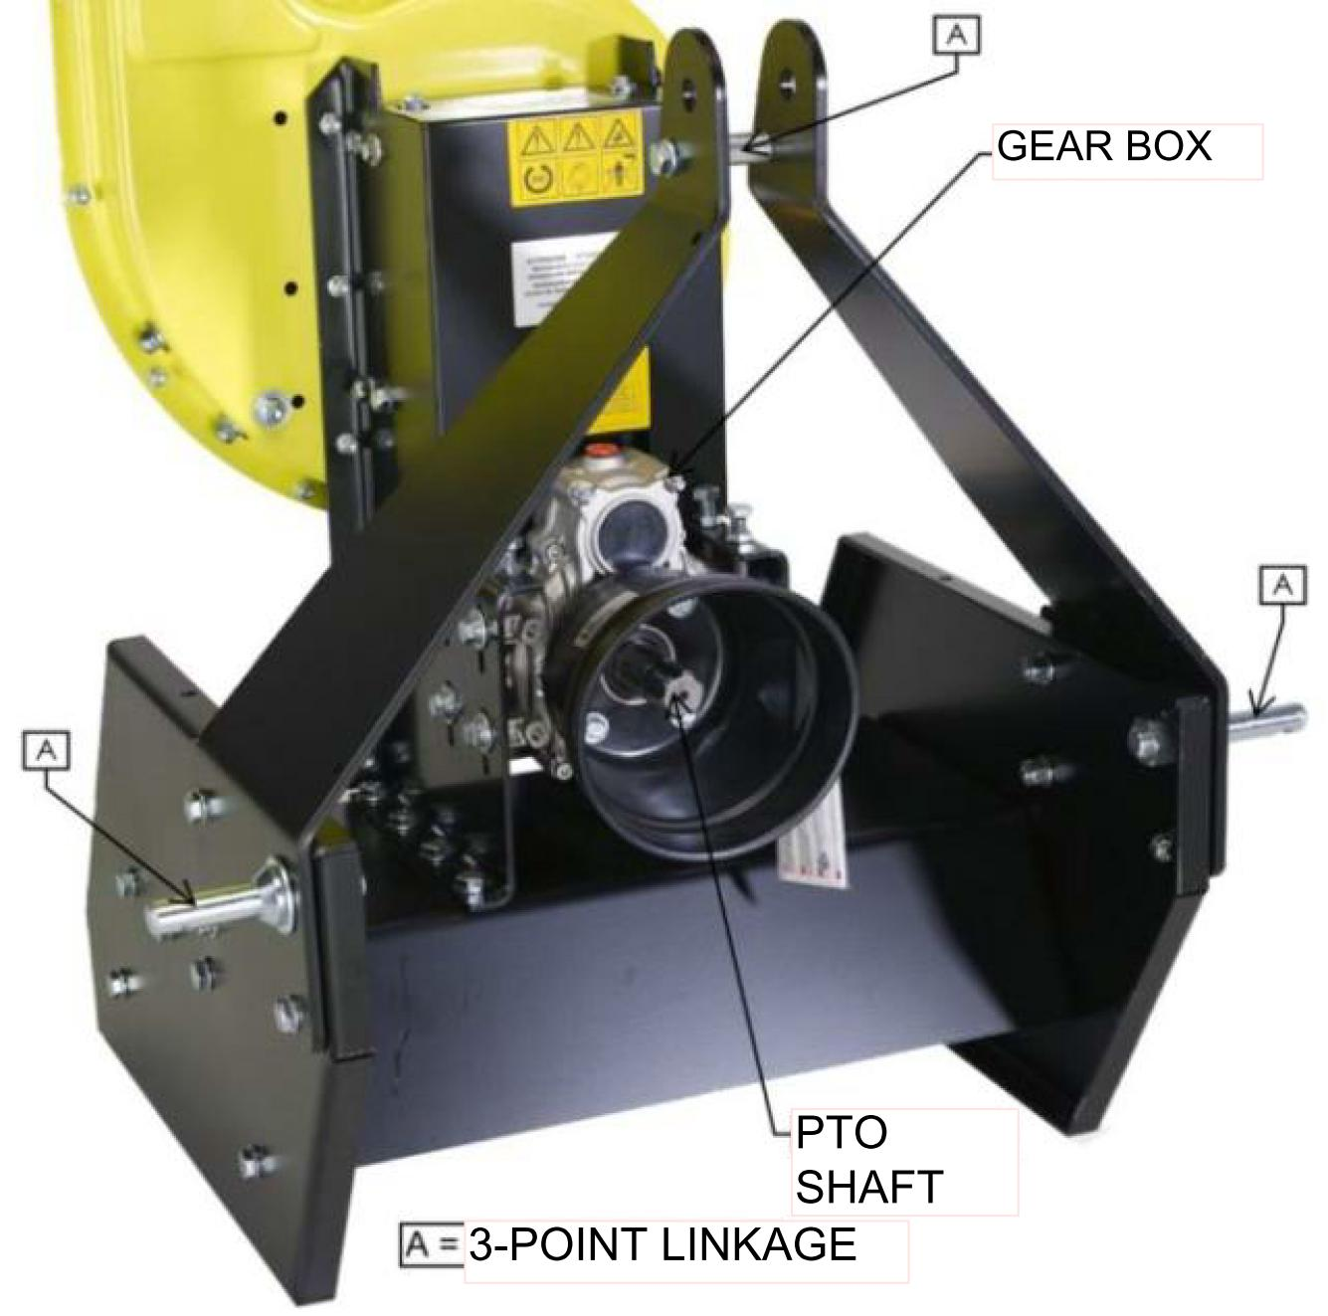
Table 1 - VERSIONS
Mod. | Engine | Engine model | HP | kW | Rpm | Weight | Ø max chopping  (average hardness  of wood )
ZE400-H  BIO400-H | Gasoline | Honda GX270 | 8.16 | 6 | 3600 | 128 | 65 mm
ZE400  BIO400 | Gasoline | B&S Vanguard | 9 | 6.7 | 3600 | 130 | 65 mm
ZE400-E*  BIO400E* | Electric | Triphase -380V | 7.5 | 5 | 2800 | 125 | 65 mm
ZE400-T1  BIO400T1 | PTO | - | min  16 | 12 | 540 | 130 | 65 mm
* Not available for the Italian market.

Table 2 - TECHNICAL SPECIFICATIONS
External Measures (rudder included)  Gasoline engine version | 2130 mm x 800 mm x 1500 mm
Engine – rotor transmission | Double belt transmission
Rotor diameter | 332 mm
Blades nr. | 2 core tempered blades
Hammers nr. | 14
Production | From 2 to 5 mc³ /h (Depending on type of worked material and operator ability)

- OPERATING PRINCIPLE

The engine through a pulley-belt system spins the cutting unit that shreds and reduce the material to work with. The material introduced in the infeed chute falls towards the cutting unit and passes first through 2 cutting knives and subsequently through the hammers that wear out and reduce the volume of material introduced.
In particular the hammers are working in conjunction with the counter-knives posts on the outskirts of the cutting chamber by contributing to refining output material.
The cutting unit also features 4 mobile wings that generate the necessary airflow to let the processed material being outputted through the discharge curve.
All this in combination with the shape of the cutting chamber consisting of 2 pressed steel shells in the shape of a snail promotes the creation of airflow, thus contributing to the optimal processing of material without clogging.

- USE ADVICES

The Bioshredder Series ZENIA, like all other machines requires a learning period by the operator in which special attention in terms of the use of security.
A correct insertion of the material is then essential for a satisfying use of the machine.

Useful advices :

- Do not put overly wet or resinous material all at once, this could block the cutting unit and carry off the engine.
If you can , switch to dry material to facilitate output.
- Do not insert overly hard material.
This could lead to corruption of knives and overload for the engine.
- Do not insert materials from pruning too leafy, if necessary, trim down the branches to not overload the machine.
- Never insert material with nails, staples, wire, dirt and stones ecc.
This could lead to corruption of knives and overload for the engine.
- If the cutting unit goes to down with the rpm , give time to the machine to discharge the processed material and let the engine regain full rpm before inserting material again.
- If as a result of an insert of resinous material or very wet you notice abnormal vibration, turn the engine off, wait until it stops completely, detach the cable of the plug (or PTO, or the power cord ) and verify that the cutting unit is not clogged and the discharge curve is free.
- WHAT IS IN THE BOX

To reduce the space required for packaging of Shredder some components are dismantled and located inside the box.
When you open the box these are the components that must be in:
- Shredder ZENIA / BIO400 series
- Use and maintenance booklet of shredder (this booklet)
- Use and maintenance booklet of engine (depends on version)
- Infeed chute and its screws
- Rudder, foot stand and its screws
- Discharge curve.
Before any type of operation you must proceed to the Assembly of Hopper, rudder ,foot stand and discharge curve.

- HOPPER ASSEMBLY

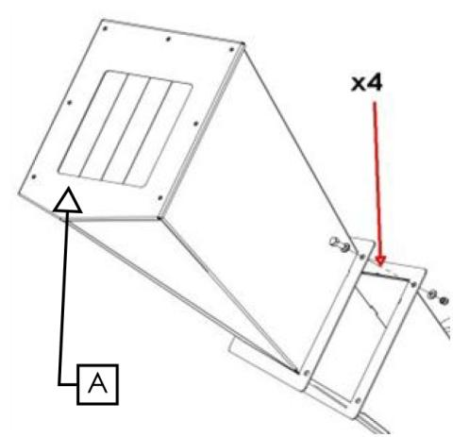
Valid for all versions.
- Take the infeed chute and bring near the machine.
- Tighten all the screws.

IT IS STRICTLY FORBIDDEN THE USE OF SHREDDER WITH CLOSING infeed chute "A" DISASSEMBLED
- RUDDER ASSEMBLY

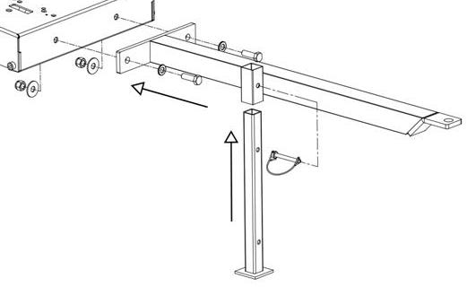
Only for engine version.
- Draw the rudder up to the bodywork and fix it by the 2 screws you have.
- Insert the foot support as you can see in the picture and stop it with the shear pin.
The foot has 2 positions you can choose:
- High: for transport/ handling
- Low: for support/ working

- DISCHARGE CURVE ASSEMBLY
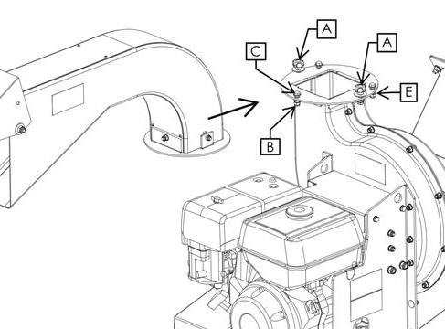
Valid for all versions.

Loosen the 2 knobs “A” without taking away completely.
Disassemble the nut “ B”
Disassemble the screw “ C”
Insert the unload curve
Re-assemble the screw “C” and the nut “B” as screws “E”.
Tighten knobs “A”

- 3-POINT CONNECTION MOUNTING

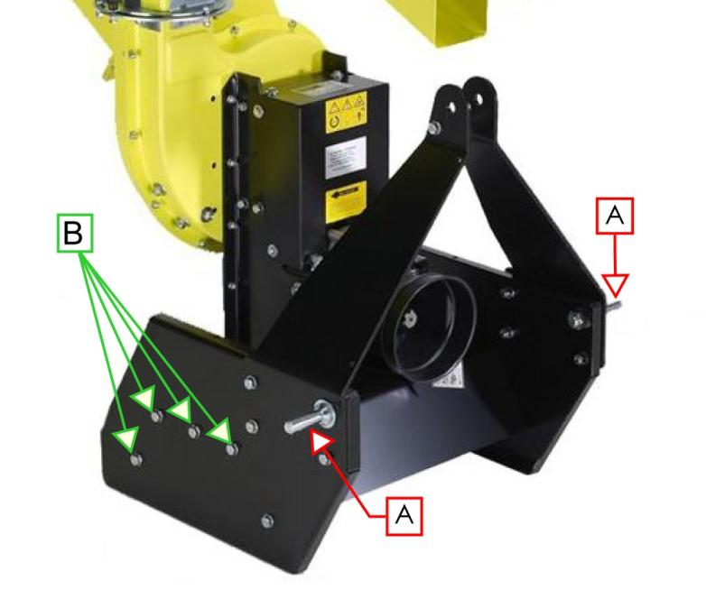

Only for tractor version.
For packaging reasons, the plugs of the connection at 3 points “A” have been assembled inside the bodywork.

IT IS COMPULSORY TO ASSEMBLE THE PLUGS OF THE CONNECTION AT 3 POINTS OUTSIDE THE BODYWORK AS IN THE PICTURE AND FIXING THEM BEFORE USING THE CHIPPER.

For packaging reasons, in some tractor version, the screws “B” ( 4 per each side) could not be assembled on the machine but kept inside a box.
Before using the machine, it is necessary to assemble the screws “B” as you can see in the picture and check their fixing well.

safety informations

Read all the instructions carefully before using the bio-shredder, in case of doubt please contact the staff of the manufacturer.
The manufacturer refuses all responsibility for not observing the safety rules and for not preventing accidents listed here below:

A correct use of the machine, A strict OBSERVANCE OF THE RULES LISTED HERE BELOW, and A strICT application of all precautions IN ORDER to prevent any dangerous situations will avoid the risk of accidents and injury, WILL allow the machine to work better and for longer and also reduce FAULTS.

All the operations will be described for the safe use of the machine, so please read them carefully.

- GENERAL SAFETY INSTRUCTIONS

DO NOT ALLOW TO USE THE MACHINE TO PEOPLE WHO DON’T KNOW THESE INSTRUCTIONS OR TO CHILDREN.

USING TO CHILDREN UNDER 16 YEARS IS FORBIDDEN.

REMEMBER THAT THE OPERATOR IS RESPONSIBLE FOR THE ACCIDENTS OR DANGERS INVOLVING OTHER PEOPLE OR THEIR OWN.

To get used to the manual before working with the machine.

- SAFETY INSTRUCTIONS - PREPARATION

- Never use the machine when there are other people, especially children, or pets in the neighbourhood;
- Do not allow children to work with the machine;
- The local rules can prescribe age limit of the operator;
- Do not make working this machine near unauthorized person;
- Do not use engine machine in a closed area because the exhaust gas contains carbon monoxide which is not colourless, odourless and tasteless; carbon monoxide is very dangerous in closed areas;
- Always wear ear protection and safety glasses each time you use the machine;
- Avoid to wear large clothes or with pending rope;
- Make working the machine only in an open space ( for example away from walls or other fixed items) and on a flat surface;
- Make working the machine on the ground, on a flat and solid surface with the brake engaged and all guards locked, in good light conditions;
- Before starting working, check all the screws, nuts, bolts and other fastenings are suitably tightened and that all guards and screens are in place. Replace damaged and unreadable labels;
- Be careful in handling fuels. They are inflammable and steams are explosive;
- Agrinova cannot consider any improper and unforeseen use involving a potential danger;
- Signals applied on the machine provide some important information: abiding by these rules is fundamental for Your safety;
- Avoid to operate on muddy, sandy or soft;
- Never use the machine to carry people, animals or objects;

- SAFETY INSTRUCTIONS – WORKING

- Before starting up the machine, make sure that the feed chamber is empty;
- Keep your face and body away from the feed opening;
- Do not insert your hands or other parts of your body into the feed chamber or the discharge chute or near moving parts;
- Always keep your balance and stability. Do not stretch out. Never stand on a higher level rather than the machine base when inserting material;
- Always stay away from the discharge area when starting up the machine;
- When putting material into the machine, be careful not to insert pieces of metal, rock, Bottles, cans or other foreign body;
- If the cutting system should come up against foreign objects or the machine should start to make strange noises or unusual vibrations, switch off the engine and stop it;
- Disconnect the spark plug cable and do as follows:
- Check the damage;
- Check and tighten any parts that have come loose;
- Replace the parts eventually damaged with parts with the same specifications;
- Do not allow processed material to accumulate in the discharge area; this situation could prevent the correct discharge, causing material return back through the feed opening;
- If the machine becomes obstructed, switch off the engine and disconnect the spark plug cable before removing any fragments. Keep the engine free from fragments in order to avoid any damage to engine or a possible fire;
- Remember that by starting the machine, the cutting device is starting at the same time;
- Keep all guards and deflectors in place and in good operating conditions;
- Never tamper with the settings of the engine regulator; the regulator controls the maximum safe operating speed and protects engine and all moving parts against damages caused by increased speed. Please contact your nearest authorized assistance once a problem occurs;
- Do not overturn the machine when engine is switched on;

- SAFETY INSTRUCTIONS – MAINTENANCE AND STORAGE

- When the machine is stopped for assistance interventions, check or storage, or to change an accessory, switch off the engine, disconnect the spark plug cable from the spark plug, make sure that all parts are no longer moving, then remove the key(if present);
- Allow the machine to cool before carrying out any inspection or adjustments;
- Put down the machine where fuel steams cannot reach any flames or sparks. If storage continues for long time, drain out the fuel. Always leave the machine cool down before;
- placing it in storage;
- During the assistance intervention on the cutting device, please remember that, even if engine does not start thanks to the option to block the guard, the cutting device can always be moved by the manual starting mechanism;

- SAFETY INSTRUCTIONS – FIRE MEASURES

- It would be better for the staff taking care of the machine to know the main procedures intervention in case of fire;
- All fuels and the great part of lubricant and hydraulic fluids are inflammable;
- Do not smoke when refilling or when topping up fluids, never fill up near flames;
- Switch off the machine engine before filling with the fuel and never fill up in closed spaces;
- Before starting the machine engine, check that there are no lack or residues of fuel/lubricants/fluids that may cause small fires;
- Do not store inflammables in spaces that are not suitable, do not pierce or burn pressurised containers or canisters, do not store up materials soaked in inflammable substances;
- Be careful with the storage of rags or replaced parts that may contain inflammable residues;
- To reduce the risk of fire to a minimum, clean the machine regularly by suitable tools ( compressed air);
- Use the proper extinguishing means: carbon dioxide, foam, chemical powder;
- Do not use jets of water. Jets of water should only be used to cool surfaces exposed to fire;
- Never use petrol, solvents or other inflammable or toxic fluids to clean mechanical parts: on the contrary, you have to use approved commercial solvents that are no-flammable and no toxic;
- Only use approved containers;
- Never remove the fuel cap or add fuel when the engine is running;
- Before filling with fuel, leave the engine and exhaust outlets to cool;
- Never leave the machine or fuel container in places where there are flames;
- If some fuel pours out, do not try to start the engine, but move the machine away from the area of the spilling before switching on;
- After filling with fuel, always close the cap and fix it firmly;
- The fuel tank must only be drained outdoor;

- SAFETY INSTRUCTIONS – STORING

- If the machine is not going to be used for a long time, it is necessary to store it in a place sheltered by atmospheric conditions and protect it against any damage;
- Before storing the machine, we recommend you to clean it and lubricating all the
- mechanical parts in order to avoid rust;
- Make sure that the storage temperature is between 0 °C and 50 °C;
- Before storing the machine for long periods, proceed as follows:
- Switch off the engine and remove the spark plug cap;
- When the engine is cool, drain out the petrol tank, well away from sources of heat, sparks and lit fires;
- Make the cutting chamber and the cutting unit free from any residues of grinding;
- Clean the machine carefully;
- Carry out a general visual inspection of the machine to identify structural damage and deep scratches in the paintwork; make sure that the original safety decals are present, undamaged and readable;
- Grease all mechanical parts, where this is necessary;
- If possible, place the machine in a covered area, on a flat and firm surface.

- SAFETY INSTRUCTIONS - SCRAPPING

If the machine is to be scrapped, it needs to be disposed of at suitable collection points, in compliance with current laws.
Before proceeding to scrap the machine, it is necessary to separate plastic or rubber parts , electrical and electronic materials from metal parts.
Recover any spent oils and dispose of them at special collection centres.

USED OIL MUST BE RECOVERED AND NEVER DISPOSED incorrectly in the environment SINCE, ACCORDING TO CURRENT LAWS AND REGULATIONS, IT IS CLASSIFIED AS dangerous WASTE AND AS SUCH, IT NEEDS TO BE brought TO A SPECIAL COLLECTION CENTRE.

When recovering used oils, it is necessary to use a “Mandatory Used Oil Consortium”.

- SAFETY INSTRUCTIONS - TRANSPORT BY VEHICLE

The transport of the machine by a vehicle has to be made exclusively when the engine is switched off and secured with ropes and all of the equipment required for the vehicle to transport it in compliance with the regulations in force.

IT IS FORBIDDEN USING THE MACHINE ON A MEANS OF TRANSPORT, SUCH AS, FOR EXAMPLE, THE BED OF A LORRY, INSIDE A VAN AND SO ON. tHE MACHINE MUST WORK ON THE GROUND, ON A FIRM AND FLAT HORIZONTAL SURFACE, WITH THE BRAKE ENGAGED AND ALL GUARDS LOCKED IN PLACE.

- SAFETY INSTRUCTIONS - ROAD TRANSIT

ROAD TRANSIT WITH THE MACHINE IS STRICTLY FORBIDDEN.
THE MACHINE CAN BE MOVED BY HAND OR TOWED BY TRACTOR OR ATV IN PRIVATE AREAS ONLY, FOR SHORT DISTANCES AND AT LOW SPEEDS.

NOTE: Wheels are suitable only for short distance. In case of transport on public road, you have to respect the highway code about the tractor versions, using safety signals, according to current laws. NOTE: It’s obligatory moving/transport the bio-shredder using all the three attacks to tractor.
SAFETY DECALS

Make sure that the safety decals are in good condition. If decals are damaged, they need to be replaced with other originals that can be required to the manufacturer and then placed in the position indicated in the use and maintenance manual.
Make sure that the safety decals are readable. Clean them using a cloth, soap and water.

- SAFETY DECALS – GASOLINE ENGINE VERSION

As follows safety decals are described, so be careful:

Cod.ET103 WARNING – DANGER Adjustment and maintenance operations must be performed after reading the use and maintenance manual, with the machine idle and the spark plug cable disconnected. Danger of flying objects. Cutting danger. Keep all the outsider at a safe distance.

Cod.ET106 WARNING – DANGER of cutting. Keep hands and feet away from cutting devices.

Cod.ET109 WARNING – DANGER of contact with moving parts. Do not put your hands near the transmission belts. Do not wear large and/or bulky clothes.

Cod.ET122 WARNING – DANGER of ejected items. Stand back.

Cod.ET201 Wear the required Personal Protective Equipment: Goggles, Headset, Gloves.

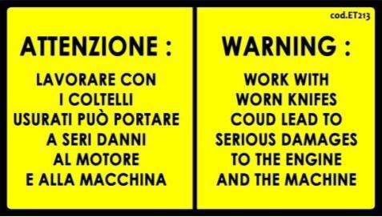
Cod.ET213 WARNING Work with worn knifes could lead to serious damages to the engine and to the machine

- SAFETY DECAL POSITION – GASOLINE ENGINE VERSIONS

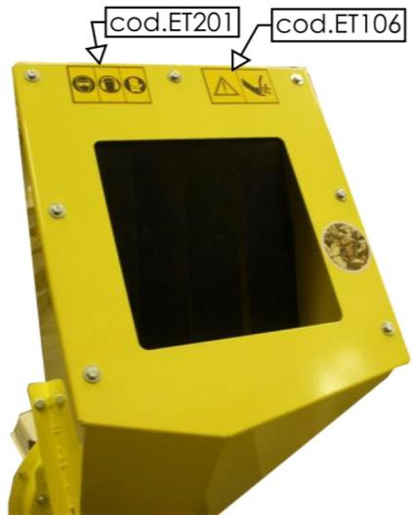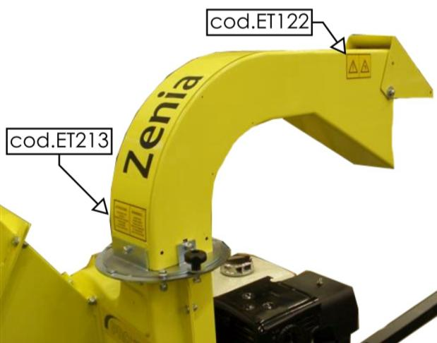
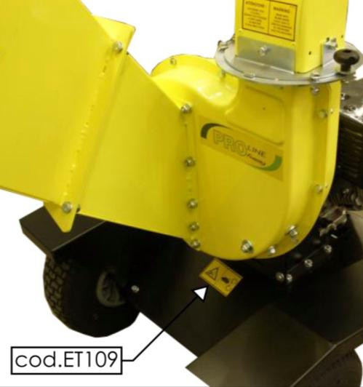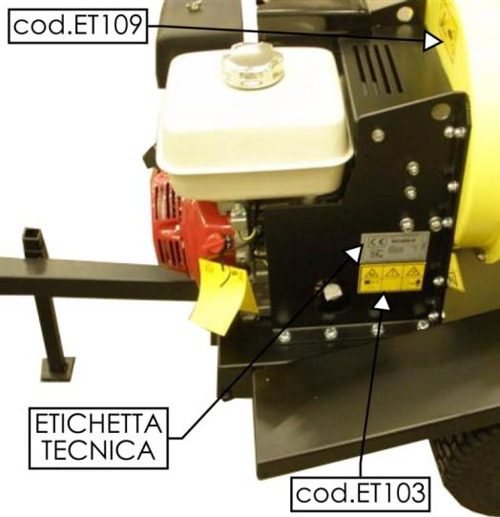
- SAFETY DECALS – TRACTOR VERSION

Cod.ET113 WARNING – DANGER MAX 540 rpm/min for PTO . use always 3-point connections. Use always safety pins . don not stand between tractor and the machine

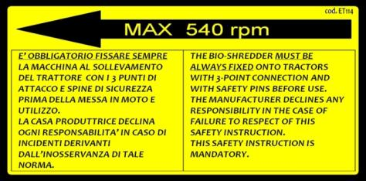
Cod.ET114 WARNING – DANGER MAX 540 rpm/min for PTO . use always 3-point connections. Use always safety pins . don not stand between tractor and the machine

Cod.ET210 WARNING - DANGER of entanglement. Cardan shaft in motion.
Stay away.

Cod.ET211 WARNING
Check oil level on the gear box every 50 hours. Use only SAE90 oil

Cod.ET106 WARNING – DANGER of cutting. Keep hands and feet away from cutting devices.

Cod.ET109 WARNING – DANGER of contact with moving parts. Do not put your hands near the transmission belts. Do not wear large and/or bulky clothes.

Cod.ET122 WARNING – DANGER of ejected items. Stand back.

Cod.ET201 Wear the required Personal Protective Equipment: Goggles, Headset, Gloves.

Cod.ET213 WARNING Work with worn knifes could lead to serious damages to the engine and to the machine

- SAFETY DECALS POSITION – TRACTOR VERSION

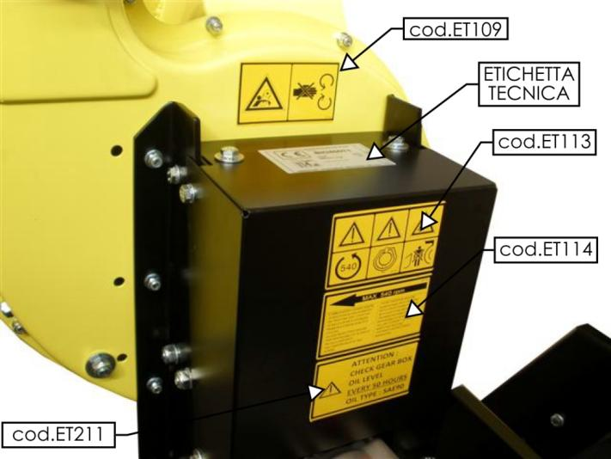

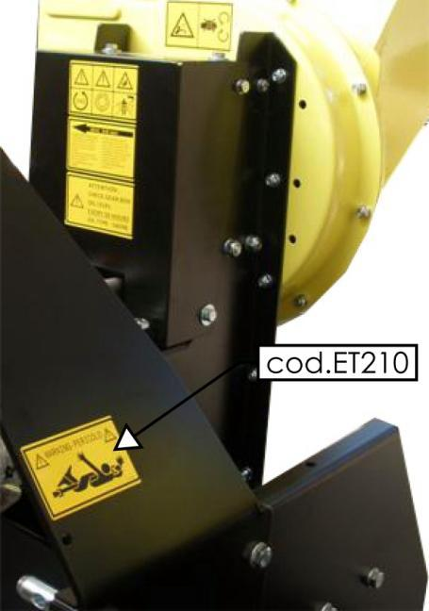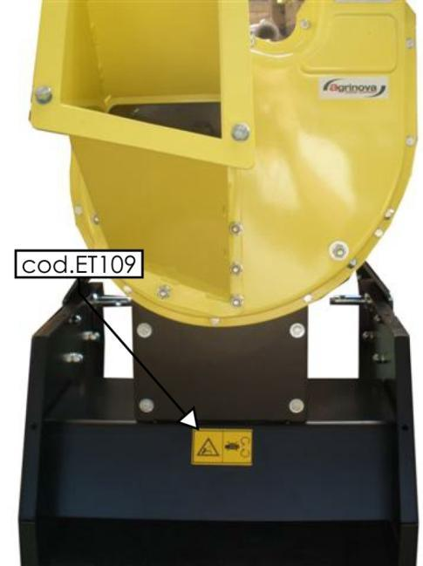
- TECHNICAL LABEL

This is the label identifying the machine and indicating the type and version, manufacture date, power, weight, noise levels and CE marking.
This label, like the safety decals, needs to be readable and in good conditions and must be placed on the machine.
If the decals are damaged, they need to be replaced with other original decals requested to the manufacturer and placed in the position indicated in the use and maintenance manual.
USE

The following section describes the operations required for the safe use of the machine.
THE MACHINE MUST OPERATE ON FLAT, FIRM GROUND WITH THE BRAKE ENGAGED AND ALL GUARDS LOCKED IN PLACE.
SPECIFICALLY, MAKE SURE THAT THE THE HOPPER, DISCHARGE PIPE AND PUMP CONTROL ROD ARE RIGHTLY LOCKED IN POSITION.
FIRMLY SECURE THE DISCHARGE CHUTE TO PREVENT ANY VIBRATIONS FROM CAUSING IT TO TURN TOWARDS YOU OR OTHERS.

To switch on, using and switch off the engine, refer to specific manual, supplied with the machine.

THE MACHINE IS DELIVERED WITHOUT ENGINE OIL.
CHECK THE ENGINE OIL LEVEL BEFORE SWITCHING ON IN ORDER TO PREVENT SERIOUS ENGINE DAMAGEs. PLEASE REFER TO THE ENGINE MANUAL FOR THE TYPE-QUALITY-AMOUNT OF OIL TO USE.
- Since the mechanical parts and hydraulic connections of the machine need time to settle in during the first stage of the machine’s useful life, it is fundamental to carry out machine checking with the utmost accuracy.
- Before using the machine, make sure that there are no people or animals in the neighbourhood.
- It is strictly forbidden removing and/or modifying protections on the machine.
- Never use the machine if you are ill, tired or under the effect of medicines, drugs or alcohol.
- Before using the machine, it is necessary to learn its layout and its functions.

  - USE

- Always wear the required protections;
- After switching on the engine and leaving it to warm up for about 2 minutes,
the machine will be ready for use;
- Take the engine to maximum running speed;
- Adjust the discharge curve and the deflector to the desired position;
- Insert the material into the infeed chute;
- At the end of use, take the engine to minimum running speed, wait for it to achieve this and then switch it off using the relevant control;
- Wait for the engine to cool before storing the machine;

The machine has been designed to work with the best performances at 3600rpm for engine version (throttle at max) and at 540 rpm/min for tractor version.

In the case of a suddenly block of the rotor,switch ofF THE engine immediatEly. let the machine cool down and CHECK the rotor by openING the upper casing. do not switch on thE machine with blocked rotor and/or open casing NOT ASSEMBLED PROPERLY.

MAINTENANCE

This section describes the machine maintenance operations, be careful.
AFTER THE ENGINE switching OFF, THE CUTTING UNIT WILL CONTINUE TO TURN FOR 10-15 secondS BEFORE STOPPING COMPLETELY. ALWAYS WAIT FOR THE CUTTING UNIT TO STOP COMPLETELY BEFORE CARRYING OUT ANY MAINTENANCE OR CLEANING OPERATION or maintenance.
all maintenance, adjustment and cleaning operations must only be carried out with the engine switched off and cool and with the spark plug cable disconnected.
IN CASE OF TRACTOR VERSION, DISCONNECT PTO AND REMOVE THE MACHINE FROM THE TRACTOR. IN CASE OF ELECTRICAL VERSION, DISCONNECT THE CABLE FROM THE PLUG.

- FIRST-TIME USING – PUTTING BACK INTO SERVICE AFTER A LONG PERIOD OF INACTIVITY

Before using the machine for the first time, or after a long period of inactivity, it is necessary to proceed as follows:

- Make sure that the machine shows no signs of damage;
- Check mechanical parts, which must be in good condition and free of rust;
- Check the blades for wear and tear;
- Carefully grease all moving parts;
- Make sure there are no oil leaks from fittings or pipes;
- Make sure all protections are correctly positioned;
- Check engine and hydraulic pump oil levels (if present);
- Carry out a general visual inspection of the machine to identify structural damage and deep scratches in the paintwork; make sure that the original safety decals are present, undamaged and readable;

- BELT REGULATION – ENGINE VERSION

With the use of the machine may need to compensate for the natural elongation of the belts usually suffer with the use of the machine through a idler. With new belt the idler is not engaged.

Each kind of maintenance intervention, regulation , cleaning, has to be carried out when the machine is switched off and cool, with the candle cable disconnected. In case of tractor version, disconnect PTO and remove the machine from tractor.

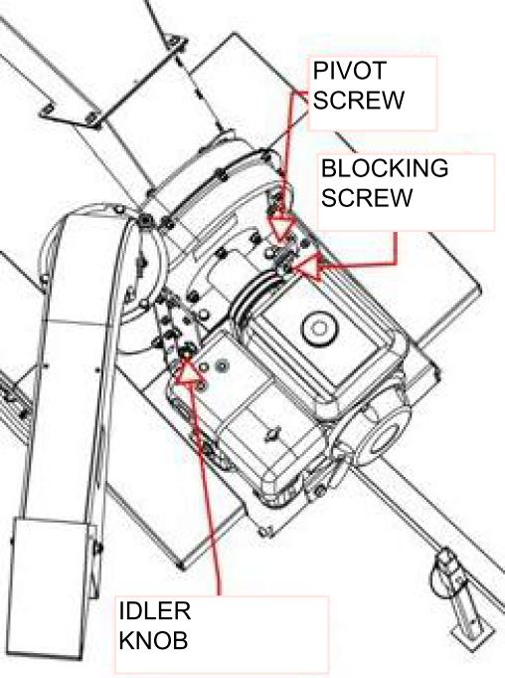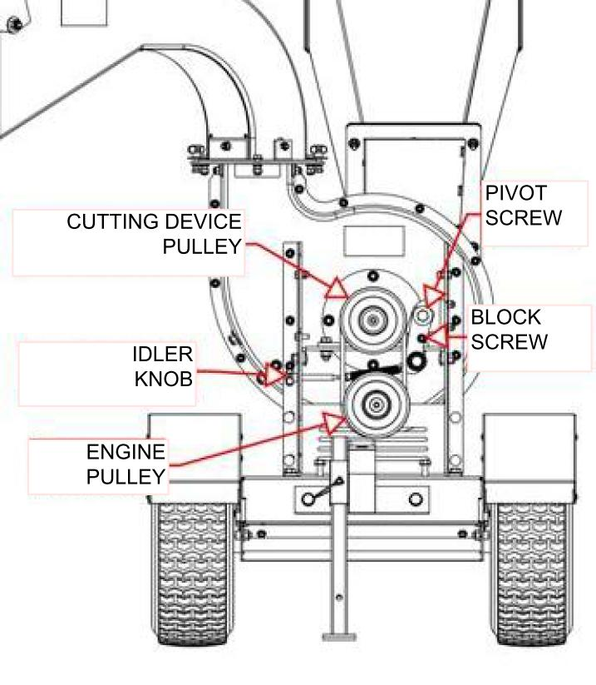
Proceed as follows:
- Disconnect superior belt protection casing;
- Identify the idler which is on the side of the belts
- Loosen the blocking screw.
- Identify the idler knob ( see the picture) on the bio-shredder’s side and rotate it clockwise in order to make the belt pulled.
- After putting the belt in tension, fix the blocking screw.
- Re-assemble the belt protection casing.
- In case of belt change , bring the belt stretching again into initial position.

- BELT REGULATION – PTO VERSION

The transmission belt regulation in tractor version has to be carried out by lowing the
Gear box.

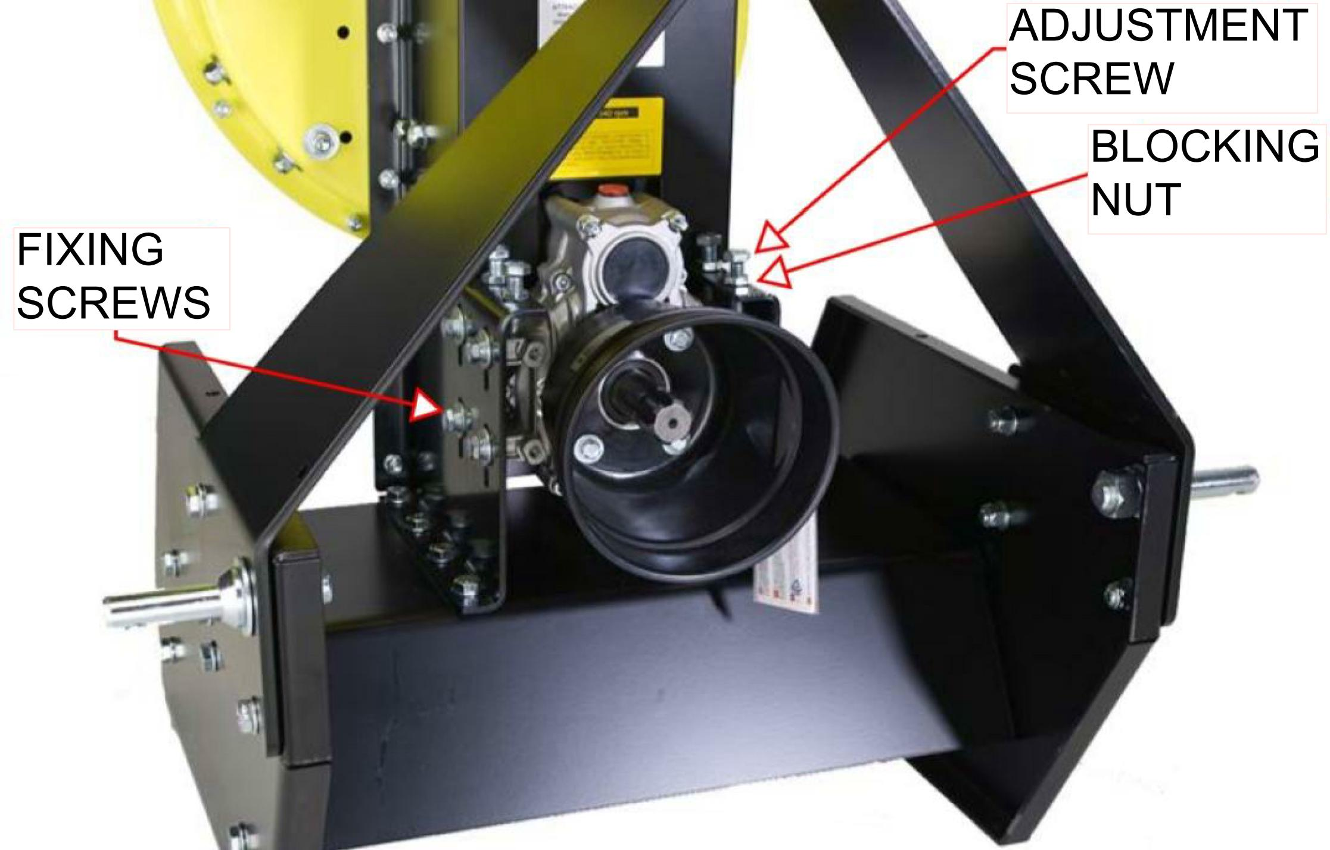

Proceed as follows:
- Loosen the multiplier fixing screws ( 4 per each side).
- Loosen the fixing nuts ( 4)
- Screw the adjusting screws in order to give more tension to belts being careful to screw all the four screws at the same way.
- Screw the multiplier fixing screws ( 4 per each side).
- Fix the blocking nuts properly.

In case of belt change, remember to raise the multiplier the highest in order to get a major adjustment field.

- CUTTING CHAMBER CLEANING – KNIFES WEAR CHECK

Regular control of knifes , cleaning the cutting devices, cleaning the cutting chamber and the discharge curve guarantee the best use of the machine and prevent from overcharge to engine and unbalancing.

Each kind of maintenance intervention, regulation , cleaning, has to be carried out when the machine is switched off and cool, with the candle cable disconnected. In case of tractor version, disconnect PTO and remove the machine from tractor.

To check how much knives are worn, proceeds as follows:
- Disassemble the discharge pipe;
- Disassemble the infeed chute;
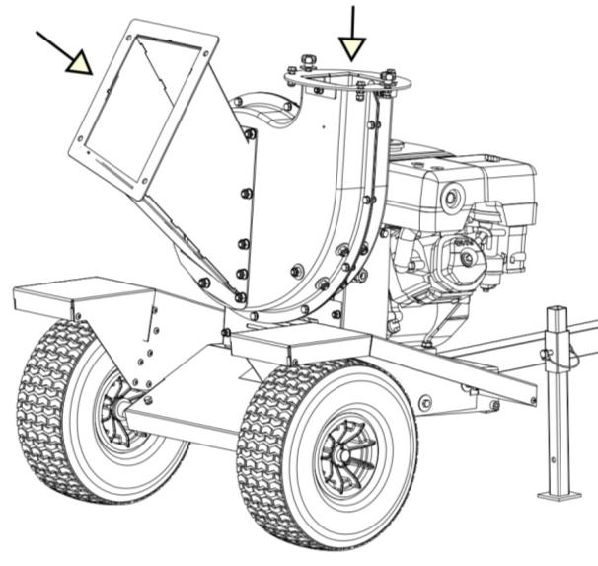
Looking through the infeed chute, you can check how much knives are worn and through the cutting area how are hammers ( see the picture above).
WARNING: DANGER OF CUTTING AND CRUSHING .BE VERY CAREFUL.
Even if engine is switched off or PTO is removed, the cutting device can anyway turn freely and cause serious dangers or accidents.

To gain the cutting device, you need to disassemble the half cutting chamber from the infeed chute side. Unscrewing at first the screw which links the discharge curve ring and then all the screws in the circle of the half cutting chamber the same.
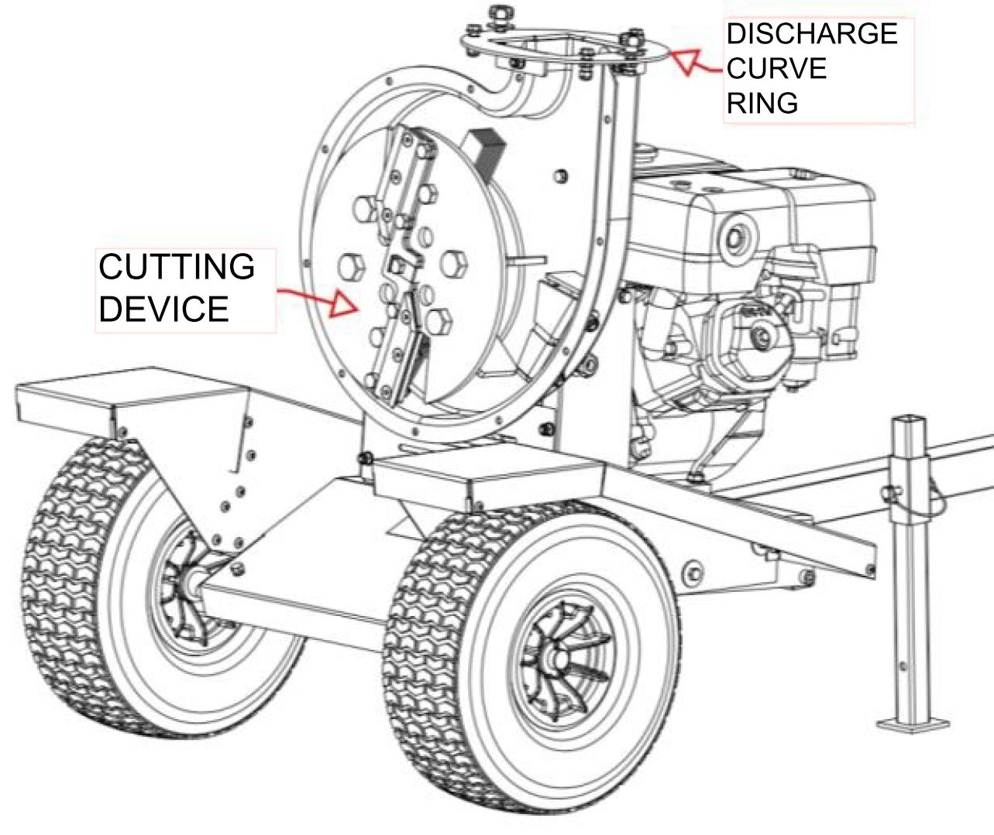
Clean properly both the cutting device and the two half cutting chamber and the discharge pipe.Check the wear and tear of knives, in case, replace them.
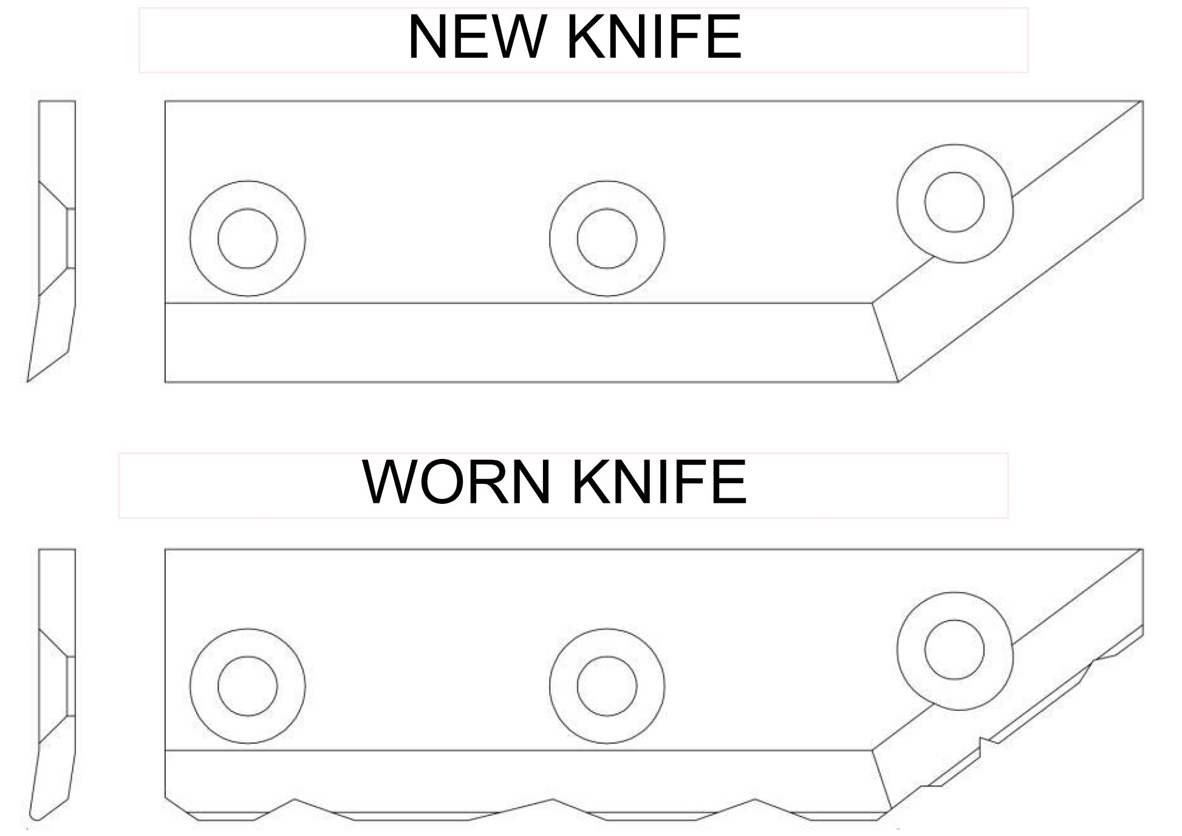

PTO VERSION

The working of the bio shredder with 3 points connections is similar to the working of
the independent engine, although further safety instructions involving the link of the
shredder to tractor, its use and moving / transport.
Read carefully and understand all the instructions described here below.

- RE-FILLING / CHECKING OIL LEVEL IN THE MULTIPLIER
THE BIO SHREDDER IS SOLD WITHOUT OIL IN THE MULTIPLIER.
BEFORE USING THE FIRST TIME, FILL WITH OIL TYPE SAE90.

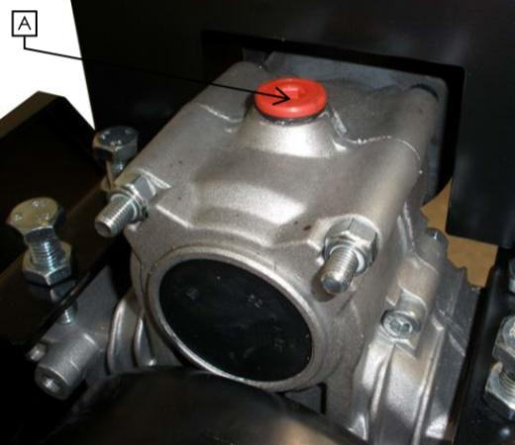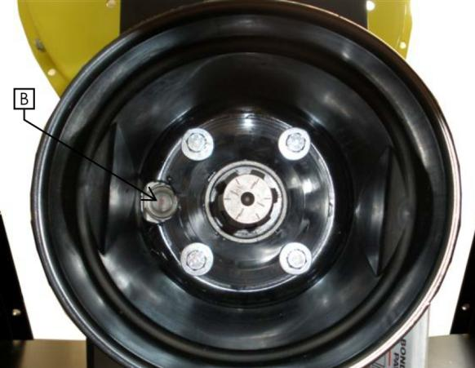

A : FILLING POINT
B : CHECK POINT
CHECK EVERY 50 HOURS OF WORKING THE OIL LEVEL IN THE
MULTIPLIER. FILLING UP, IF NECESSARY, WITH OIL OF A GOOD QUALITY
TYPE SAE90.

- ADDITIONAL SAFETY INSTRUCTION – PTO VERSIONS

- Read the instructions on the safety labels of PTO and follow them with great care.
- Read the instructions in the use and safety manual of the cardan joint and follow them with great care
- Read the instructions in the use and safety manual of the tractor to whom the bio shredder will be connected and follow very carefully.
- Use only cardan joints respecting the safety level as mentioned in regulations in force.
- Be careful when you use PTO.
- Keep the bystander, especially children and/or no-operator, away from the transmission line of PTO and the bio shredder.
- It is obligatory to connect the Bio shredder and the tractor using all 3 points connection, according to rules in force.
- Check that the link between the bio shredder and the 3 points connection has been carried out properly, keep in safety the connection pins with their own safety plugs.
- Check that the link between the bio shredder and the tractor by the cardan joint has been carried out properly.
- Check that the cardan joint respect all the safety instructions according the rules in force, that all the protections and safety chains are in good conditions and link correctly.
- Keep always all the carters and protection screens in position when using the machine.
- Disconnect PTO, switch off the tractor, remove the switching on key, disconnect the cardan joint and make sure that all the moving parts are completely stopped before removing carter and protection screen and before doing every maintenance, control and cleaning action.
- Clothes worn by the operator have to be perfectly close-fitting.
- Never wear: jackets, shirts, belts, large trousers, working around PTO and/or the cardan joint.
- Link your long hair behind the back of the neck or put them under a cap.
- Avoid that hydraulic pipes, electric cables, chains, ropes and other things get in touch with PTO and the cardan joint.
- Do not exceed in speed than 540+-10 revolutions per minute about PTO.
- Check the correct cardan joint rotation.
- Keep your hands, feet and clothes away from all the components of PTO transmission and of the cardan joint.
- Do not clean, lubricate or adjust the cardan joint when it is working.
- Keep away from the moving parts.
- The bio shredder has a mass of about 130 kilos, so it is necessary to verify that the tractor has a power and a mass suitable for connection/transport/ using of the bio shredder.
- In case of transport on a public road by a tractor, respect all the highway code rules, using the adequate signs of advice and danger, according to rules in force.
- IT IS STRICTLY FORBIDDEN using the bio shredder moving, the tractor has to be stopped and braked, on a flat surface, away from any any kind of obstacles.
- IT IS OBLIGATORY moving/transport the bio shredder using all 3 points connection.

The machine has to be linked to the tractor power takeoff of at least 16HP with a speed equal to 540 rpm. The rotation sense of the tractor power takeoff has to be clockwise to an observer that is looking at the power takeoff in front.
It needs to be used a cardan joint with some features correspondent to rules in force.
Check these features directly from documents of the tractor and from the same cardan joint. Always verify, in every case, the efficiency of the protection carter on the power takeoff of the Tractor, on the chipper and on the cardan joint.
All the transmission unit has to be protected.

The transmission at cardan joint could be very dangerous in the case that some safety rules are not observed. In the instruction manual you will find more prescriptions about the cardan joint.
First of all we recommend you to check that the carter on the tractor side and on the bio shredder side are efficient, that are no cracks and bad working.
Verify that the power takeoff protection of the bio shredder integrate itself and is superimposed for at least 50 mm as in the picture below.
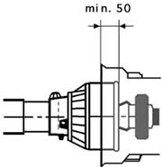

- LINK – START – OPERATING STAGES - STOP

After reading and well understood this instruction manual and following all the safety prescriptions is possible to proceed with the connection and use of the bio shredder.

- Check the good conditions of carters and protection screens.
- Check the oil level of the multiplier .If it is necessary you have to fill up.
- Connect the bio shredder to the tractor by the 3 points connection.
- Connect the cardan joint to PTO and to bio shredder.
- Switch on the tractor and engage PTO.
- Take gradually revolutions of PTO to 540 rpm.
- Never go beyond 540 rpm.
- Put the material into the hopper.
- When you finish your work, you have to tick over the engine, disconnect PTO and switch it off.
- Wait the rotation of PTO and all moving parts has been stopped before doing any intervention.
- At the moment of depot: disconnect the cardan joint, disconnect the 3 points connection being careful to put away the safety pins and plugs.

SPARE PARTS

Repairs and replacements must be carried out using original spare parts, which must be requested from AGRINOVA s.r.l. or an authorised dealer of same. Remember that the request for replacement parts needs to be accompanied by the following information:
machine type;
serial number;
date of purchase;
WARRANTY

For the product warranty, refer to the European standard 99/44 and its implementation in Italy.
To avail of the warranty service supplied by the manufacturer, the operator must scrupulously abide by the precautions stated in the Use and Maintenance Manual and specifically:

- comply with the limits to use as envisaged by AGRINOVA s.r.l.;
- do no make any changes or variations to the machine without any written approval of AGRINOVA s.r.l.;
- always carry out all of the prescribed maintenance interventions;
- always use original spare parts;
- make sure that those people using the machine meet the necessary requirements in terms of skill and training.

The warranty will not apply in the event that any of the above conditions has not been complied with, even partially.
The warranty does not cover possible defects that could result from uncorrect use and it will be null and void in the event of repairs, changes or any other kind of intervention not performed by AGRINOVA s.r.l. or by one of its authorised dealers.
The use of spare parts not authorised by the manufacturer will void all warranties as well as freeing the manufacturer or dealer of any liability arising from malfunctions or accidents.
Removing or changing guards or protections will free the manufacturer of any liability for damages caused to people and/or property.
The warranty does not cover parts that are subject to wear and tear, such as (this list includes but is not limited to the following): blades, belts ……The engine warranty is applied and managed by the assistance network of the engine manufacturer.

EC DECLARATION OF CONFORMITY

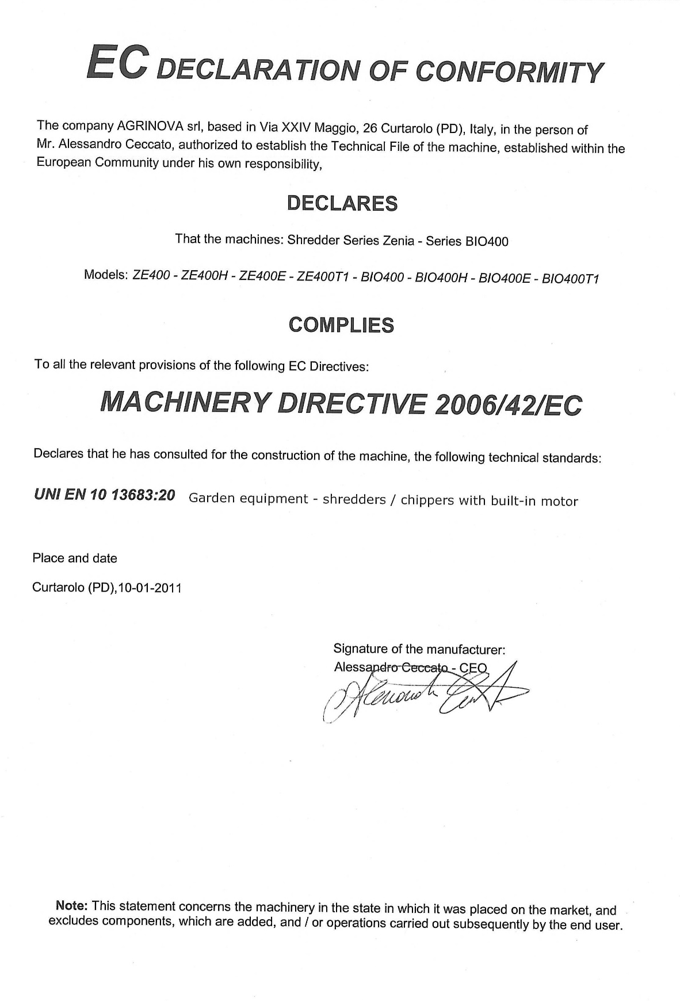

CONTACTS

Agrinova s.r.l.
Via XXIV Maggio, 26
35010 Curtarolo (PD) ITALY

Tel. +39 049 5742645
Fax. +39 049 5742646

Email : agrinova@agrinova-italia.it
Web : www.agrinova-italia.it

